# KlasikoPinas: Filipino Traditions

**and Mythical Creatures Digital Game**

A THESIS

Presented to the

The Faculty of the College of Computing Studies

Don Honorio Ventura State University

In Partial Fulfillment

of the Requirements for the Degree

Bachelor of Science in Computer Science

By:

**Basilio, Crisanto S.**

**Malveda, Limwell Jake P.**

**Pineda, Raymund Paolo I.**

**Ramirez, John Russel B.**

**Sanchez, Seinthe R.**

**Santos, Francis Ford L.**

January 2022

# ACKNOWLEDGEMENT

We, the proponents, would like to express our warmest thanks and appreciation to Mr. Eden Garcia, thesis adviser, and Ms. Aileen P. De Leon, thesis instructor, who made this work/thesis possible. Their active advice, guidance and essential directions carried the researchers through all the stages of completing their job. Also, our heartfelt thanks to all the respondents for taking part in the study and providing information throughout the field work.

We also would like to express our deep sense of gratitude to our parents/guardians for their unwavering support; financially, emotionally, and spiritually, and most of all their unconditional love, which is more than enough as we overcome all the hurdles in completing this research study.

Above all, to the Great Almighty, for keeping all the circumstances in favor of us and letting us complete our thesis successfully.

# 

# TABLE OF CONTENTS

TITLE PAGE i

ACKNOWLEDGEMENT ii

TABLE OF CONTENTS iii

LIST OF TABLES v

LIST OF FIGURES vi

Abstract 1

Introduction 2

Objectives of the Study 8

Scope and Delimitations 8

Significance of the Study 9

Conceptual Framework 10

Definition of Terms 11

Methodology 12

Data Gathering Procedure 12

Statistical Analysis 14

Software Development Methodology 16

Required Specification and Analysis 18

Implementation Plan 22

RESULTS AND DISCUSSION 24

Game Evaluation 33

CONCLUSION AND RECOMMENDATIONS 38

Summary of the Findings 38

Conclusion 39

Recommendations 39

References 41

APPENDICES 44

Appendix A: Pre-Survey Questionnaire 44

Appendix B: Game Evaluation 46

Appendix C: Game DFD(Level 0) 48

Appendix D: Game Flowchart 49

Appendix E: Storyboard Application 50

Appendix F: GUI Screenshots 55

Appendix G: Codes 69

Appendix H: Curriculum Vitae 81

# LIST OF TABLES

**Table 1**: Evaluation of Likert Scale for Pre-Survey Questionnaires 16

**Table 2**: Evaluation of Likert Scale for the assessment of the game 16

**Table 3**: Evaluation of Likert Scale for the interpretation of the game 17

**Table 4:** Hardware Specifications 20

**Table 5**: Software Specification 21

**Table 6:** Gender of the Respondents 25

**Table 7**.What platform/device do you usually use playing video games? 27

**Table 8**:How often do you play games? 27

**Table 9**: Are you aware of the Filipino mythical creatures? 28

**Table 10:** How often do you play traditional games? 30

**Table 11**: What kind of games do you usually play? 31

**Table 12**: According to the last question, do you think playing those video games allows you to gain valuable knowledge? 33

**Table 13:** Evaluation of the Functionality of the Game 34

**Table 14**: Evaluation of the Accessibility/Visual Design of the Game 35

**Table 15**: Evaluation of the Stability and Performance of the Game 36

**Table 16**: Summary of the criteria/category of the Game quality 37

# LIST OF FIGURES

**Figure 1*.*** *Game Conceptual Framework* 10

**Figure 2**.*Agile Methodology* 18

**Figure 3.** *Game Implementation Plan* 23

**Figure 4.** Age of the Respondents 26

**Figure 5.** *Which of the following mythical creatures are you familiar with?* 29

**Figure 6.** *Which of the following traditional games have you played?* 30

**Figure 7.***Which of the following games have you already played?* 32

**Figure 8**. *Main Menu of the Game* 51

**Figure 9.** Game Selection 52

**Figure 10.** Shop Game 53

**Figure 11.** Theme Selection in the Game’s Shop 54

**Figure 12.** Option of the Game 55

**Figure 13.** Main Menu of the Game 56

**Figure 14.**Selection Game 57

**Figure 15**. Mythical Creatures in Shop 58

**Figure 16**. Themes in the Shop 59

**Figure 17**. Option in the game 60

**Figure 18.** Palo Sebo Game 61

**Figure 19.** Sipa in the game 62

**Figure 20.** Luksong Baka in the game 63

**Figure 21.** Langit Lupa in the game 64

**Figure 22.** The cave in the game 65

**Figure 23.** Victory UI in the game 66

**Figure 24.** Fail UI in the game 67

**Figure 25**. Purchased Unsuccessful UI in the Shop 68

**Figure 26.** Purchased Successfully UI in the game 69

# Abstract

As the digital games became more apparent over the years, generations became more interested and hooked to these games. As a result, traditional games that have been a vital part of every Filipino childhood and mythological creatures and their folklores that symbolize our forefathers' traditions and culture are gradually being disregarded. These customs play a significant factor in having our own cultural identity. It is critical for current and future generations that research is performed to determine the best approaches for maintaining this heritage in an era when modern digital games have grown in popularity. This study, entitled "KlasikoPinas: A Digital Game on Filipino Traditions and Mythical Creatures," was created to remind Filipinos of their cultural roots and educate them about various Filipino Traditional Games and Mythical Creatures. Furthermore, the development tools used were Godot Engine for coding, Blender for creating and animating the character, Audacity for sound design, and Sketchbook for the design. This study used quantitative approaches to collect data, which included a pre-test and post-test design. The evaluation used by the proponents was based on the Software Product Quality defined in ISO/IEC 25010. The proposed game was evaluated with the aid of 178 respondents who tested the game for functionality, accessibility/visual design, and performance/stability. The game's functionality got a score of 2.81, it’s interpreted as *Good*. For the visual design/accessibility of the game, with a mean of 2.67, which is interpreted as *Good*. Lastly, the performance and stability of the game have a mean of 2.68, interpreted as Good. The game has an overall mean of 2.72 which is interpreted as Good in the rating scale of the system.

*Keywords: Filipino traditions, traditional games, mythical creatures, digital game, Godot engine, KlasikoPinas*

# Introduction

The Philippines has a long and enduring history of establishing its deeply rooted culture. The blend of western and Asian cultural ideals makes the Philippines culturally rich and unique to this day (Masanga, 2021). Many aspects of a country can contribute to its culture, one of which is the traditional games and mythical creatures. After all traditional games are viewed as the finest platform for promoting peace, harmony, goodwill, and camaraderie. Traditional Filipino games, also known as indigenous games in the Philippines, are frequently played with native materials or instruments. *Piko, patintero, taguan, tumbang preso, siato, sipa, and luksong tinik* are some of the country's most popular and well-known traditional games. Though there are limited materials, Filipinos keep the joy of youth because of the games invented by their ancestors. Youth assemble in the streets or on the neighborhood playground to participate in these Filipino games. They are popular and beloved pastimes among many Filipinos, particularly older generations. Philippine myths continue to play a significant part in the lives of rural Filipinos to this day. Numerous myths circulating throughout the rural areas of the Philippines feature a diverse array of mythological beings. The Filipinos have a variety of mythological creatures they believe in, including *Aswang*, *Manananggal, Kapre, Duwende, Sirena, Siyokoy, Engakanto, Sigbin*, and *Tikbalang*. The entities are believed to act as divine providers, and some are viewed as villainous that cause misfortune and troubles to townspeople. The Filipinos' various beliefs in the supernatural are attributed to the old folktales that were told in their childhood or to Filipinos' creative minds and storytelling abilities (Diamante, 2019). The Philippines was once a divided collection of nations, islands, and tribes; each has its monarchs, chieftains, lakans, rajahs, datus, and sultans. This era, however, did not last long, as the invaders' incursion was successful. The oppressor saw the "natives" as inferiors during over 350 years of colonialism, and this attitude of inferiority persists long after these states have become dependent on them. Since then, the Philippines has been on a search to discover its own identity.

In Philippine society, playing games is an integral part of growing up. Some are challenging, some are delicate, some are physical, and some are mentally stimulating. Without a doubt, the accessibility of technology has dramatically impacted the quality of life of many. However, with the advent of technology, the opportunity for the younger generation to genuinely appreciate their rich culture has dwindled. Nowadays, most kids are playing through their mobile gadgets; they are starting to forget the existence of our traditional games. Mobile applications are more valuable and convenient to use than old things used by the old generations (Autriz et al., 2016). This issue could lead to the loss of identity of one's country, as culture plays a vital role in developing a specific community and society. Moreover, one of the essential elements in understanding one's culture is the presence of indigenous and traditional games (Hortelano et al., 2015). The modernization caused the existence of traditional games began to shift due to the existence of technology which developed the game to be modern in the current global era. The advancement of technology makes it easy for children to access the internet and easily enjoy modern games such as online games, video games, etc. The development of the modern era also led to the erosion of traditional art, including traditional games (Wiyono et al., 2020). The reasons why traditional games need to be preserved are regarding the various noble meanings that are contained in traditional games, such as religious values, educative values, norms, and ethics, which those are. According to Santos et al. (2019), to conserve traditional culture, current, and future researchers must seek a way to discover strategies to preserve cultural heritage in an era where new digital games are becoming increasingly popular.

Over the last decade, Philippine games have become widespread recreational activities in the country. Studies have shown that traditional games have a tremendous positive impact on persons' cultural and overall development (Thompson, 2016). As a result, Philippine games are becoming less popular, while computer games and other less demanding activities are becoming increasingly popular among Filipino youngsters. Balite & Robles (2020) extrapolate that Philippine games are vital for cultural preservation and education, yet they appear to be unfamiliar to today's youth. They also recommend that entities should pay closer attention and take action in support of Philippine games in order to preserve the conservation of indigenous Filipino culture. At the end of this, traditional games are not widely played or even unknown to children. This is due to the increasing usage of electronics and online gaming from a young age.

As technology became more and more accessible to the population of all ages came the tremendous rise of video games. Video games are becoming an increasingly central part of everyone's cultural lives, impacting various aspects of everyday life such as our consumption, communities, and identity formation (Muriel & Crawford, 2018). Filipinos nowadays prefer playing inside and playing mobile games and PC games (Elliot, 2020) stated that 74% of the Philippines’ online population play games on mobile, 65% play PC games. According to (Angeline, 2016) playing digital games also offer experience and satisfaction based on interactive communication technologies and immersive gameplay. Immersion was greater with video and written text than with the digital game, although games led to much stronger experiences of embodied presence (Riet et. al, 2018). The motive of this could be attributed to the technological advancement over the recent years. (Deloso, 2020) stated that play has always been part of human learning. The idea of play has been utilized in different mobile and computer applications to provide learning and health promotions. Technologies like gamification and augmented reality increase interactivity as well as attention span among the learners (Marcial, 2021). It’s the reason why people of all ages tend to prefer this medium over that of others. Furthermore, digital gamification in the classroom is a teaching strategy that translates content and delivery into a game using digital technology. According to (Angeles 2020), the top 10 games (Valorant, Genshin Impact, Ragnarok M, Roblox, Wild Rift, Dota 2, LoL, MLBB, PUBG, COD) in the Philippines are all online games. The majority of them fall under the category of aggressive games. With these types of games (Quwaider et al. 2019) stated that it assessed internalizing behavior problems such as anxiety, depression, and over controlled behaviors, and externalizing problem behavior such as aggressive, hyperactivity, noncompliant, and uncontrolled behaviors. Exposure to this violent kind of video game increases their risk of engaging in real-world violence and imitating aggressive or violent behaviors from the video games. According to (Zwier, 2019) Video games are influential and are not troubling, but it is worth exploring the ways in which video games are changing players’ actions, attitudes, and ideals through covert persuasion. Video games have the capacity and potency to transmit and instill prejudicial attitudes in players through covert persuasion, and these attitudes can lead to destructive actions.

As the digital era progressed, certain established traditions, such as traditional games and folklore, began to fade away slowly (Mohamed & Tajuddin, 2019). Playing local games as recreation can lead to enhancement of each contribution towards sustainability of local culture and awareness of ecological goods and services. However, with the current technologies that surround everybody, there is a probability local practices will be left out (Bejerano & Buot, 2018). In accordance with Hidayati (2020) traditional games are inherited from ancestors which are not only used for entertainment, but contain values and messages contained in them. With the lack of something we can call our own, most Filipinos develop a colonial mentality, to which they prefer “western country” over the Philippines' own. Consequently, Filipinos began to lose contact with their deeply rooted culture. People neglect the rich heritage of its numerous ethnic groups and, in the process, disregards traditional Filipino games and mythological creatures.

Given that video games have historically been seen negatively, it is critical to focus attention on the beneficial effects on a person's habit of learning. As has been noted, the proponents see this as a chance to build an educational game that promotes the region's traditional games and mythological creatures. Since video games offer a more pleasurable and immersive experience than other forms of entertainment, the general population prefers the benefit it brings. In their study, Castillo et al. (2019) determined that when educational mobile applications were utilized to play games, it improved a student's learning. Video games, through their widespread popularity and appeal, transmit meaningful ideas, beliefs, and attitudes via the use of digital worlds, narratives, characters, and play. Not only can video games serve as a form of escapism, but they also provide a variety of ways for users to connect with the social reality – close or far – that pervades individuals. With the help of the digital entertainment industry, people can share their fictional stories about Filipino mythical creatures with more creativity (Quina, 2021). As stated by Ali & Jeu (2018) folklore in the digital form of video games could be used as a digital entertainment instrument to integrate cultural awareness, people's beliefs, and information. Undoubtedly, video games can consume the attention of children and adolescents. However, it is vital to assess the extent that video game technology had an impact on childhood education. Since video games can engage children in learning experiences, this has led to the rise of “edutainment” media (Grifith, 2002). Just by watching children, it becomes apparent that they prefer this type of approach to learning. Besides, the younger generation's tendency to overlook traditional games became more apparent over the years as the advancement of digital games progressed. In his study, Ascunscion et. al (2019) they suggest that despite 56.66 % of their participants still playing traditional Filipino games, there is now a thin margin that, if left unchecked, would be worrisome in the coming years. Provided that, to some extent, video games could impact the culture or brand of a nation itself. In her study, Lasausse (2018), identifies the distinctive role of video games in the context of brand image and country representation. The study explores a link between the current approach of country branding and the ancient idea of mythology and folklore, and its relevance in the image of Nordic countries, both inside and outside the area, through video games. Therefore, the study focuses on digital games as their function has dramatically improved, other than playing the game as entertainment. However, now the game has become one of the practical tools to convey the message to the public.

## Objectives of the Study

The objective of this game is to achieve the following:

* To develop a fun and casual game that focuses on Filipino traditional games and its mythical creatures.
* To encourage the gamers to play educational games instead of aggressive and violent games. Combat features would be excluded from the game, and it would instead focus on completing tasks and completing objectives to receive prizes to learn the concepts of the traditional games and mythical creatures included in KlasikoPinas.
* To familiarize and inform the players the rich traditional games and mythical creatures of the Philippines by making the game engaging, challenging, and captivating to the players.

## Scope and Delimitations

KlasikoPinas is a cross-platform (Android/Microsoft Windows) offline, casual, and educational game. The game's environment is three-dimensional, while the gameplay is two-dimensional. It contains challenges and level stages. In their study, Balite and Robles (2020) infer that Luksong Baka, Langit Lupa, Sipa, Piko, and Patintero were relatively familiar the most amongst their respondents. As a result, the game incorporates four (4) traditional Filipino games: Langit Lupa, Luksong Baka, Palo Sebo, and Sipa. Additionally, the game included mythical creatures such as *Siyokoy, Aswang, Duwende* — a Filipino version of gnomes, dwarves, or leprechauns —, *Engkanto —* associated with the spirits of ancestors in the Philippines characterized as spirit sorts like sirens, dark beings, elves, and more —*, Kapre, Tikbalang, Sirena —* A Filipino counterpart of English Mermaind —*, Manananggal*, and *Santelmo*. They are capable of being bought in the game, providing intriguing facts and knowledge to the player when they are purchased. The in-game shop will give information on the mythological creatures, allowing gamers to become familiar with them. Traditional Filipino games such as *Patintero*, *Luksong Tinik,* *Piko, Tagu-taguan, Sungka, Syato, Tumbang Preso, Ten-Twenty* were excluded in the game. Moreover, other mythical creatures such as *tiyanak*, *batibat*, and so on would not be part of the game.

## Significance of the Study

As the prevalence of the digital entertainment industry became more apparent and relevant, younger generations gradually started to overlook their well-established culture and traditions such as Filipino Traditional Games and Mythical Creatures. To older generations, this game allows them to relive their childhood experiences. It will enable more youthful generations to delve into the distinction of the Philippines' rich culture, which can aid the country's development toward establishing its own identity. This study is significant to the following:

**Gamers:** The game helps players by allowing them to engage in an enjoyable and educational game rather than an aggressive game.

**Academic Researchers:** The study improves the researcher's ability to think critically about game development. This work may serve as one of the foundations around which future academics develop a new game that establishes cultural beliefs and traditions. **Generation Alpha:** The study benefits them because this generation grew up in electronic games. It will help them to learn and get familiarized about the rich Traditional Games and Mythical Creatures of the Philippines.

## Conceptual Framework

**Figure 1*.*** *Game Conceptual Framework*

Figure 1 shows the conceptual framework. The proponents used the IPO model (Input, Process, Output), a function graph that required processing to transform inputs into outputs. All the provided materials in the input will process through Systems Development, System Design, and Testing. After the processing, a game will be developed.

## Definition of Terms

**Agimat:** Filipino term for “Amulet” or “Charm.”

**Gamification:** To boost involvement, incorporate game concepts into non-game contexts such as a website, online community, learning management system, or a company’s intranet.

**Mythical Creatures:** A legendary creature is a supernatural animal or paranormal entity, generally a hybrid, sometimes part human, whose existence has not or cannot be proven and that is described in folklore (including myths and legends), but also may be featured in historical accounts before modernity.

**Generation Z:** Generation Z, often known as zoomers, is the demographic group that follows the Millennials and comes before Generation Alpha.

**Larong Pinoy:** the Filipino term for the indigenous games played mainly by the youth to promote a healthy lifestyle, friendship among the community and enjoyment of the Filipinos through outdoor activities.

**Casual Game**: a video game intended towards the public, as compared to a hardcore game aimed at hobbyist gamers. They usually have fewer rules, shorter sessions, and need less skill to learn.

**Forefather:** a member of the past generations of one's family or people; an ancestor.

# Methodology

This chapter consists of the methodology used in the proponent's study. The section presents the selected research design, research method, and the research instrument to collect data. Moreover, this will provide the study's specifications, analysis, statistical treatment of data, and implementation plan.

**Research Design**

The proponents utilized the applied research design because it aims to solve actual issues in the real world rather than collecting data for the sake of collecting data. According to Edgar & Manz (2017), applied research is the process of quantifying how well we applied the knowledge we have learned from basic science to solving some problem. Also, applied research entails the development, implementation, and evaluation of systems. While applied research frequently employs rigorous experimental methods, it is primarily concerned with determining the performance of an engineered system or application.

The proponents’ goal of developing a game based on market demands complements the aim of applied research to solve a specific, practical issue affecting an individual or group. This research design focuses on obtaining information about market demands. Identifying solutions to the problem is done by enhancing and developing new products aligned with the objectives of the proponents.

## Data Gathering Procedure

The respondents selected were from Filipinos that play games and use Android smartphones or Windows computers, to which they can access the internet to download the game. Devices that run in Android and Windows are qualified to partake. Regardless of the respondent’s knowledge of Filipino culture, they will still be considered a potential player of the game. Thus, the proponents disseminated the questionnaires via Facebook groups, Messenger group chats, and Discord—a gamer-oriented messaging application—servers that include the proponent’s respondents.

The respondents completed two surveys as part of the study: a pre- and post-survey. A research instrument is a tool used to collect, measure, and evaluate data from research respondents. This study utilized the quantitative method of research through questionnaires. Due to the current pandemic, the questionnaire was distributed online to the proponent's target respondents through Google Forms.

Sampling is a method of choosing individuals or a subset of the population to make statistical inferences and estimate population characteristics. This survey sampling method requires researchers to have prior knowledge about the purpose of their studies so that they can properly choose and approach eligible participants for surveys conducted using online surveys (Alchemer, 2021). The researchers take advantage of the appropriateness of the purposive sampling technique to the study’s target locale. Purposive sampling is a non-probability sampling—which involves non-random selection—which correlates to the chosen target locale. The approach enables the researcher to extrapolate data necessary to the current state of the study to enhance it further

## Statistical Analysis

Likert scale is an orderly scale on which respondents select the item that most strongly supports their point of view. The total number of sample sizes utilized in the study ranged from a minimum of 140 and maximum of 200 respondents. As said by [DiGirolamo](https://www.researchgate.net/profile/Joel-Digirolamo) (2018), a general rule of thumb is to have 10 times the number of respondents as items a researcher wants to factor analyze. There are a total of 14 questionnaires included in the study, and in order to obtain the best sample size, the proponents adopted the strategy of scaling each item by 10. This approach assesses a person's attitude by determining how they agree or disagree on the given topic or statement.

To assess the game, the proponents employed a four-point Likert Scale for target respondents. The choices range from "Strongly Disagree" to "Strongly Agree." The weighted mean was employed by the researchers to determine the measure of respondent perceptions.

Weighted Mean = $\frac{\sum_{i=1}^{n}{ (x_{i}*w_{i})}}{\sum_{i=1}^{n}{w}}$

Where:

∑ = summative

Xi = values of attitude

Wi = weight for each value.

Furthermore, the proponents used the percentage formula to interpret results in the preliminary survey questionnaires.

P = $\frac{f}{n}$ $x 100$

Where:

P = percentage

f = frequency or number of respondents

n = total number of respondents

**Table 1***: Evaluation of Likert Scale for Pre-Survey Questionnaires*

|  |  |  |
| --- | --- | --- |
| Weight/  Scale | Mean  Range | Verbal  Interpretation |
| 4 | 3.40 - 4.0 | Always |
| 3 | 2.60 - 3.39 | Frequently |
| 2 | 1.80 - 2.59 | Sometimes |
| 1 | 1.00 - 1.79 | Rarely |

**Table 2**: *Evaluation of Likert Scale for the assessment of the game*

|  |  |  |
| --- | --- | --- |
| Weight/  Scale | Mean  Range | Verbal  Interpretation |
| 4 | 3.40 - 4.0 | Strongly Agree |
| 3 | 2.60 - 3.39 | Agree |
| 2 | 1.80 - 2.59 | Disagree |
| 1 | 1.00 - 1.79 | Strongly Disagree |

To get an overall assessment of the proposed game's functionality, stability, and accessibility, the following conversion table for calculated mean is used:

**Table 3**: *Evaluation of Likert Scale for the interpretation of the game*

|  |  |  |
| --- | --- | --- |
| Weight/Scale | Mean Range | Verbal Interpretation |
| 4 | 3.40 - 4.0 | Excellent |
| 3 | 2.60 - 3.39 | Good |
| 2 | 1.80 - 2.59 | Fair |
| 1 | 1.00 - 1.79 | Needs Improvement |

## Software Development Methodology

The proponents used agile methodology because of its adaptability, flexibility, and versatility to the demands of the game. This method will be iterative rather than document-based (Figure 2). The production process is broken down into small iterations and concentrates on the most vital aspects of the product. Furthermore, this method considers the unstable nature and unpredictability of video games and depends on “empirical control process”. More specifically, feedback loops are important when applying this methodology as they provide information to the developers and guide them over what attributes need to be changed or fixed (Archontakis, 2018). It also employs an incremental development strategy to lower the complexity of the game. Continuous planning, testing, integration, and other kinds of progressions are all part of this method. Each task divides into numerous iterations spanning a given amount of time. This method makes it easier for teams to adapt to changes and make necessary adjustments. The proponents use kanban — a popular workflow management method used to implement agile and lean software development methodology that focuses on just-in-time delivery of functionality and managing the amount of work in progress. Kanban helps the proponents keep an eye on the game’s progress and improves the team’s productivity. On a kanban board, required tasks are visually displayed, allowing team members to view the status of each task at any moment.



**Figure 2**.*Agile Methodology*

**Plan**

The proponents gather themselves for a brainstorming session in the title proposal. After brainstorming, they came up with a game featuring Filipino traditional games and Filipino mythical creatures.

**Design**

The proponents used Blender and Sketchbook for the characters and items’ visuals. The Godot game engine will be the software used to create the game. The most powerful desktop computer that the proponents own renders the 3D models used in the game. Blender, Godot, and Sketchbook are used to construct the game, which requires computers.

**Develop**

The proponents started coding in parallel with the production of the visuals with the help of a kanban board and a Git repository hosted by Github; to keep the development consistent among the proponents. Throughout the development cycle, there is constant brainstorming and discussion of the mechanics.

**Test**

The proponents tested the game on a Windows and Android device to check for bugs or errors encountered while playing the game. Furthermore, the proponents ensure that the game is stable and compatible with the previously mentioned device platforms before release.

**Deploy**

The proponents will release an alpha version of the game to the respondents that sent their email via pre-survey questionnaire.

**Review**

After the respondents have gained access to the game's alpha version, the proponents will send them an invitation to provide feedback.

## Required Specification and Analysis

The game is a casual and educational one in which the user can select from a variety of traditional games. After completing a task or objectives, the player will receive a pearl, which functions as a currency. The player would encounter a set of goals and challenges. As they may then learn more about the mythical creatures by purchasing them in-game, players could be familiar with traditional Filipino games and mythological creatures.

**Table 4:** *Hardware Specifications*

|  |  |  |
| --- | --- | --- |
| **Hardware** | **Specification (Minimum)** | **Usage** |
| Condenser Microphone | Microphone Material: Steel + Zinc Alloy  Microphone Stand Material: Metal  Sound Card Material: Metal  Polar Pattern: Uni-Directional  Frequency Response: 20Hz-20KHz | Utilized to record the voice-overs in the game |
| Personal Computer/ Laptop | Operating System: Windows 10 and Linux  RAM: Minimum of 4 gigabyte.  ROM: 250 Gigabyte disk space.  Graphics Card: DirectX 11 compatible and onwards and at least 2GB of video RAM.  CPU: At least Intel Core i5 for 3D work | Utilized in the whole process of game development |
| Android Phones | Android version 6.0 | Utilized for the testing of mobile platform version of the game |
| Graphic Tablet | Resolution (LPI): 4000  Pressure Sensitivity: 2048 levels of pen pressure  Report rate speed (RPS): 220  Area: 10'' x 6''  Function Keys: 16 Function Keys | Utilized to draw and sketch the design of the models, environment and assets of the game. |

**Table 5***: Software Specifications*

|  |  |  |
| --- | --- | --- |
| **Software** | **Specification (Minimum)** | **Usage** |
| Godot | Godot Version 3.2 | Utilized for the development of the game. It's also used to bring the game to life by providing the physics engine, sound, scripting, animation, artificial intelligence, 3D model manipulation, and its tree scene, all of which contribute to the game's development. |
| Blender | Blender Version 2.9 | Utilized for making 3D models of the game. |
| GitHub/Git | Git Version 2.33  GitHub version 2.9.6 | Utilized for the proponent's collaboration of the project with Kanban Board. It also documents all the logs of each proponent's contribution to the project. Furthermore, it allows the proponents to see the changes made to each file on the project, making it easier to troubleshoot any issues that arose throughout the game's development. It also serves as the repository of the game. |
| Sketchbook | Sketchbook Version 8.8.0.0 | Utilized for making concept arts, Icons, and Background of the game |
| Audacity | Audacity Version 3.1.3 | Utilized for the recorded audio editing |

The proponents used Godot as the game engine, Blender for modeling, and Sketchbook to draw concept arts. The hardware needed to develop the game in Windows computers capable of running the required applications.

**Game Data Flow Diagram (Level 0)**

Game inputs are collected from the player to interact with the game, which then the game responds to the player. This cycle continues until the player unlocks all the game's contents and can still replay the traditional games introduced prior.

**Game Flowchart**

As the end-user opens the game, they’ll choose from a play button that directly goes to the traditional games. The other is a shop button; if the player selects the shop button, the game will show the in-game shop, containing various items that entail information about the Filipino mythical creatures. The player must firstly have enough pearls that can be earned playing the traditional games. The traditional games have specific goals and tasks, and if the player completed the game, the player would receive a pearl that serves as a currency to buy items in the in-game shop.

## Implementation Plan

**Figure 3.** *Game Implementation Plan*

Figure 5 above shows how the respondents can access the game. When the game is ready for release, the game will be uploaded in itch.io. The user can download the game from the site.

# RESULTS AND DISCUSSION

This section presented and analyzed the gathered data from their selected respondents. The outcome indicates both how the planned approach was established, and which elements of the project need to be addressed in the present manual method. To convey the findings in a methodical and meaningful way, tables and figures are used.

The table below summarizes the results of the preliminary questionnaires completed by the respondents.

|  |  |  |  |
| --- | --- | --- | --- |
| Gender | Number of Respondents  (f) | Total Size of Respondents  (n) | Percentage  (P) |
| Male | 103 | 141 | 73% |
| Female | 38 | 141 | 27% |

**Table 6:** *Gender of the Respondents*

From the table 6, we can conclude that 103 out of 141 respondents are male which makes it 73% and the rest 38 respondents are female which is 27%. The purpose of this survey is to ascertain the sexual orientation and percentage of target respondents who have played games; nevertheless, the ratio of respondents is reasonable given that females generally do not play as many games as males. The purpose of this survey is to get the sexuality and the ratio of the target respondents that have play games, as many as there are however quite fair since the females relatively don’t play many games as much as the males.

**Figure 4.** Age of the Respondents

The purpose of this questionnaire is the know is to profile the age of target respondents who completed the survey. Based on the Figure 4, out of 82 responses the group age that have the most are ranging from 18-22 years of age with a total of 65 respondents. Ages from 14-18 have 11 respondents, and ages above 22 have 15 respondents’ total. The finding suggests that majority of gamers are in the age group of 18-22.

*Findings of the Preliminary Questionnaire No.1*

|  |  |  |  |
| --- | --- | --- | --- |
| Device/Platform | Number of Respondents  (f) | Total Size of Respondents  (n) | Percentage  (P) |
| Windows/PC | 6 | 141 | 4.3% |
| Android/Smartphone | 92 | 141 | 65.2% |
| Both A & B | 43 | 141 | 30.5% |

**Table 7**.*What platform/device do you usually use playing video games?*

Out of all the 141 respondents, the table 7 shows that 92 of the respondents (65.2%) utilize Android platform and Smartphone device for play video games, Windows platform/PC device with only 4.3% (6 out of 141), and 30.5% of the respondents use both options. Through this finding, the proponents conclude that the market of both Android and Windows is big, so that is why the proponents took advantage of it and the game will be built on both platforms.

*Findings of the Preliminary Questionnaire No.2*

|  |  |  |  |  |  |
| --- | --- | --- | --- | --- | --- |
| Always  4 | Frequently  3 | Sometimes  2 | Rarely  1 | Mean Value | Verbal Interpretation |
| 61 | 58 | 21 | 1 | 3.26 | Frequently |

**Table 8**:*How often do you play games?*

As shown in Table 8, a number of 61 out of 141 respondents answered *always*, 58 respondents answered *frequently*, 21 respondents answered *sometimes*, and 1 respondent answered *rarely.* With the computed weighted mean of 3.26, the verbal interpretation for how often the respondents plays games is *frequently*. The purpose of this questionnaire is to identify how popular a digital game towards today’s generation. The findings indicate that the video games are preferred by people nowadays as it provides entertainment, learning, and satisfaction.

*Findings of the Preliminary Questionnaire No.3*

|  |  |  |  |
| --- | --- | --- | --- |
| Answer | Number of Respondents  (f) | Total Size of Respondents  (n) | Percentage  (P) |
| Yes | 47 | 141 | 33.3 |
| Somewhat | 94 | 141 | 66.7 |
| No | 0 | 141 | 0.0 |

**Table 9**: *Are you aware of the Filipino mythical creatures?*

Based on table 9 above, most respondents have a moderate knowledge of the Filipino mythical creatures, with 109 amongst 141 students answering *somewhat (70.85 percent), along*with 28.6 percent of respondents, *yes,*and no one respondent responded *no*. The question was conducted to understand further the familiarity of the respondents with Filipino mythical creatures. Additionally, the finding demonstrates that a significant portion of culture, such as Filipino mythical creatures, is mostly neglected; hence, the proponents chose to incorporate Filipino mythical creatures into the game.

*Findings of the Preliminary Questionnaire No.5*

**Figure 5.** *Which of the following mythical creatures are you familiar with?*

According to figure 5, approximately more than half of respondents are familiar of mythical creatures such as siyokoy (69.5 percent), tikbalang (66.7 percent), kapre (69.5 percent), manananggal (64.5 percent), tik-tik (69.5 percent), duwende (66.5 percent), engkanto (71.6 percent), aswang (59.6 percent), and sirena (58.2 percent), while only 0.7 percent of total respondents responded none. The numbers provide insight into which mythological creatures would be featured in the game.

*Findings of the Preliminary Questionnaire No.6*

|  |  |  |  |  |  |
| --- | --- | --- | --- | --- | --- |
| Always  4 | Frequently  3 | Sometimes  2 | Rarely  1 | Mean Value | Verbal Interpretation |
| 5 | 2 | 44 | 90 | 3 | Sometimes |

**Table 10:** *How often do you play traditional games?*

Based on the table 10 above, out of the 141 respondents just five replied *always*, two responded *frequently*, 44 answered *sometimes,* and 90 respondents responded *rarely* of playing traditional games*.* With the mean of value of 3, the verbal interpretation for how commonly respondents engage in traditional games is *sometimes*. This statistic solidifies the argument that traditional games are being overlooked. Hence, the proponents decided to develop a video game that features traditional games.

*Findings of the Preliminary Questionnaire No.7*

**Figure 6.** *Which of the following traditional games have you played?*

Based on figure 6, about two traditional games are over the 70th percentile of the survey, namely: langit lupa and tagu-taguan. Meanwhile, the other traditional games like patintero, piko, sipa, luksong baka, and tumbang preso have been played by over the 55th percentile of the respondents. The figure shows the Filipino traditional games that are prevalent amongst the respondents. By doing so, the proponents acquire insight into popular traditional games and select langit lupa, luksong baka, and sipa to incorporate into the game.

*Findings of the Preliminary Questionnaire No.6*

|  |  |  |  |
| --- | --- | --- | --- |
| Category | Number of Respondents  (f) | Total Size of Respondents  (n) | Percentage  (P) |
| Casual/Educational | 54 | 141 | 38.3 |
| Role Playing Games (RPG) | 25 | 141 | 17.7 |
| Multiplayer Online Battle Arena (MOBA) | 43 | 141 | 30.5 |
| First Person Shooting (FPS) | 18 | 141 | 12.8 |
| Real Time Strategy (RTS) | 1 | 141 | 0.7 |

**Table 11**: *What kind of games do you usually play?*

Based on table 11 above, 38.3 % of the 141 respondents preferred Casual/Education games, 30.5 % played Multiplayer Online Battle Arena, Role Playing Games were picked by 17.7% of the respondents, and just 0.7% for Real-Time Strategy Games. The purpose of this questionnaire is to determine which type of game is the most popular among respondents. With this finding, the proponents extrapolate that a casual/educational game would benefit the proposed game.

*Findings of the Preliminary Questionnaire No.7*

**Figure 7.***Which of the following games have you already played?*

As shown in the figure 7, Mobile Legends and Call of Duty have a tremendous lead compared to the other games in the list out of 141 respondents, 78% and 72.2% respectively have already played it, placing the two at the top as the most popular games in the questionnaires. Whereas games such as Dota 2 was played 27.7%, League of Legends only 22%, Genshin Impact with 24.8%, and 21.3% of the respondents played Counter Strike. The questionnaire's purpose is to ascertain the kind of the games that the majority of target respondents prefer. The findings indicate that most respondents enjoy aggressive games, suggesting that the current trend in digital games is impacting traditional Filipino games.

*Findings of the Preliminary Questionnaire No.7*

|  |  |  |  |
| --- | --- | --- | --- |
| Answer | Number of Respondents  (f) | Total Size of Respondents  (n) | Percentage  (P) |
| Yes | 4 | 141 | 2.8 |
| Somewhat | 83 | 141 | 58.9 |
| No | 54 | 141 | 38.3 |

**Table 12**: *According to the last question, do you think playing those video games allows you to gain valuable knowledge?*

From table 12 above, just 2.8% of the respondents have learned something valuable from the aggressive games mentioned in the previous findings. However, 58.9% have said that they *somewhat*gain some knowledge while playing these games. At the same time, 38.3% of the total respondents responded that they had not learned valuable playing the games mentioned earlier. This result proves that playing aggressive games could not be reliable when developing a game whose primary goal is to impart the slowly fading traditions of a country.

## Game Evaluation

The tables below illustrate the respondents' viewpoints on the functionality, accessibility/visual design, and performance of the proposed game. Rating scales and overall evaluation was shown on table 1 and table 2 of the methodology.

**Table 13:** *Evaluation of the Functionality of the Game*

|  |  |  |  |  |  |  |
| --- | --- | --- | --- | --- | --- | --- |
| Questionnaires | Strongly  Agree  (4) | Agree  (3) | Disagree  (2) | Strongly Disagree  (1) | x | Verbal Interpretation |
| **Functionality** | | | | | | |
| The game accurately explains the user's task and goal | 4 | 143 | 11 | 20 | 2.74 | Agree |
| All games, regardless of their difficulty level, bring satisfaction | 17 | 100 | 46 | 15 | 2.67 | Agree |
| The game is enjoyable and good. | 26 | 109 | 34 | 9 | 2.85 | Agree |
| The game helps to familiarize with different Filipino traditional games and mythical creatures. | 49 | 84 | 36 | 9 | 2.97 | Agree |
| The game provides detailed representation of Filipino traditional games and mythical creatures. | 43 | 88 | 39 | 8 | 2.93 | Agree |
| The game keeps my curiosity and drives me to play more. | 16 | 104 | 48 | 10 | 2.71 | Agree |
| Grand Mean | | | | | 2.81 | Good |

The quality model is the cornerstone of a product quality evaluation system. The quality model determines which quality characteristics will be considered when evaluating the properties of a software product (ISO/IEC 25010). In software product quality evaluation, the functionality of a system is the ability of the product to do the work for which it was intended. It should cover and facilitate all the specified tasks and user objectives (ISO/IEC 25010). Table 13 shows the frequency distribution, mean, and verbal interpretation of the respondent's assessment of the functionality of the proposed game. The functionality criterion got a grand mean of 2.81, which indicates that the proposed game functionality is Good.

**Table 14**: *Evaluation of the Accessibility/Visual Design of the Game*

|  |  |  |  |  |  |  |
| --- | --- | --- | --- | --- | --- | --- |
| Questionnaires | Strong  Agree  (4) | Agree  (3) | Disagree  (2) | Strongly Disagree  (1) | x | Verbal Interpretation |
| **Accessibility/Visual Design** | | | | | | |
| The game provides a clear and precise instructions | 5 | 120 | 43 | 10 | 2.67 | Agree |
| The game is simple to play and has a basic objective. | 11 | 109 | 47 | 11 | 2.67 | Agree |
| The game is sufficiently visible and quick to navigate. | 9 | 106 | 56 | 7 | 2.66 | Agree |
| The game is intuitive and user friendly. | 11 | 100 | 47 | 20 | 2.59 | Disagree |
| The game is interactive and entertaining | 14 | 123 | 19 | 22 | 2.73 | Agree |
| Grand Mean | | | | | 2.67 | Good |

The accessibility/visual design of a system should compose of attributes that make it easy to operate and control. Also, the user interface enables pleasing and satisfying interaction for the user. Moreover, the product is used by people with the widest range of characteristics and capabilities to achieve a specified goal in a specified context of use (ISO/IEC 25010). Table 14 displays the frequency distribution, mean, and verbal interpretation of the respondents' judgment of the proposed game's accessibility/visual design. The accessibility/visual design category scored a grand mean of 2.67; respondents rated the proposed game's accessibility/visual design as *Good*.

**Table 15**: *Evaluation of the Stability and Performance of the Game*

|  |  |  |  |  |  |  |
| --- | --- | --- | --- | --- | --- | --- |
| Questionnaires | Strongly  Agree  (4) | Agree  (3) | Disagree  (2) | Strongly Disagree  (1) | x | Verbal Interpretation |
| **Stability and Performance** | | | | | | |
| The game operates great on my smartphone. | 10 | 111 | 37 | 20 | 2.62 | Agree |
| The game responds quickly and does not lag. | 6 | 110 | 62 | 0 | 2.68 | Agree |
| The game runs smoothly on my device | 5 | 129 | 40 | 4 | 2.75 | Agree |
| Grand Mean | | | | | 2.68 | Good |

Performance as a software quality attribute refers to the timeliness aspects of how software systems behave. Performance refers to responsiveness: either the time required to respond to specific events, or the number of events processed in a given interval of time (Smith). Performance is that attribute of a computer system that characterizes the timeliness of the service delivered by the system. Table 15 represents the frequency distribution, mean, and verbal interpretation of respondents' ratings of the proposed game's performance and stability. The performance and stability criteria scored a grand mean of 2.68, indicating that the proposed game has *Good* performance and stability.

**Table 16**: *Summary of the criteria/category of the Game quality*

|  |  |  |
| --- | --- | --- |
| **Category/Critiria** | **Weighted Mean** | **Verbal**  **Interpretation** |
| Functionality | 2.81 | Good |
| Accessibility/Visual Design | 2.67 | Good |
| Performance and Stability | 2.68 | Good |
| Overall Mean | 2.72 | Good |

The proposed game was reviewed by 178 people that tested out the game for functionality, accessibility/visual design, and performance/stability. The game application obtained an acceptable rating based on the system's evaluation analysis. The game's functionality received a rating of 2.81, which is considered satisfactory and equates to *Good* on the rating scale. The evaluators gave the game a *Good* rating for visual design/accessibility, with an average mean of 2.67, since the Graphical User Interface (GUI) design worked well, and the game's ease of use is acceptable. Finally, the game's performance and stability have an average mean of 2.68, which is considered *Good*. The evaluators gave it a favorable rating because the game ran smoothly on the user's device and had no issues. In the system's rating scale, the game has an overall mean of 2.72, which corresponds to *Good*.

# CONCLUSION AND RECOMMENDATIONS

This chapter presents the overall summary of the study; it consists of the outline of the findings and conclusion. It also features all the recommendations for future researchers to assist them with their research.

## Summary of the Findings

The purpose of this study is to educate people/gamers about the rich and entertaining customs of the past that are progressively being ignored by today's generation as digital entertainment becomes more prevalent. Every person has a device to which they can access online games at a moment's notice. Thus, these changes affected certain established traditions such as traditional games and folklore. The proponents proposed a 2.5D game which is basically about traditional games and mythical creatures of the Philippines. The mythical creatures are purchasable items in the shop that provides information about them. The games include the history and mechanics of the traditional game.

The game had undergone evaluation to ensure the quality of the game application. The evaluation used by the proponents was based on the Software Product Quality defined in ISO/IEC 25010. The proposed system was evaluated with the aid of 178 respondents who tested the proposed system for functionality, accessibility/visual design, and performance/stability. Based on the evaluation analysis of the project, the game application received an acceptable result. The game's functionality got a score of 2.81, which is relatively acceptable and interpreted as Good. The evaluators have positive feedback as the game contains User Interface (UI) that enables the user to know objectives and enables the user to understand these customs and their values. For the visual design/accessibility of the game, with an average mean of 2.67, the evaluators rated the game with the interpretation of Good, as the design of Graphical User Interface (GUI) worked well, and its ease of use is manageable. Lastly, the performance and stability of the game have an average mean of 2.68, which is interpreted as Good. The evaluators have evaluated it neutrally as the game was performing well without bugs on the user's device. The game has an overall mean of 2.72 which interpreted as Good in the rating scale of the system.

## Conclusion

KlasikoPinas, a 2.5D educational game, promotes the generational customs disregarded in today’s generation. The game was designed with the history, mechanics, and gameplay features of four traditional Filipino games, namely: Palosebo, Sipa, Luksong Baka, and Langit Lupa, and mythical creatures that remind us of our roots. As modern-day Filipinos have preferred modern games such as Mobile Legends:BangBang (MLBB) and Call of Duty Mobile, the KlasikoPinas, educational games have rated positive feedback on the gamers with an overall mean of 2.72. Hence, the game was Good and delivered to impart the rich traditions that past generations played a massive part in their cultural identity.

## Recommendations

The proponents suggested additional features of the application to improve the project, based on the findings of the respondents' questionnaires, the game's evaluation, and during the process of developing the game.

* The proponents recommend adding more traditional games like patintero, luksong tinik, siyato, and other traditional games, for more variety and additional entertainment.
* The proponents suggest adding more purchasable mythical creatures and making the item in the shop have more functions that can contribute to the player's progress.
* The proponents advocate adding an achievement rewards system to share the user's progress as players tend to have a feeling of accomplishment on their hard work.
* The proponents advocate creating multiplayer gameplay as traditional games are meant to be played with a friend. Hence, the game would be more interactive and can be enjoyed with others.
* The proponents commend having a leaderboard to add more competitiveness to the game.

# References

Ali, M. F., & Jeu, P. N. (2018, November). A Malaysian Folklore Game Design As A Tool Of Culture Preservation And Entertainment: Toyol. *Advances in Social Science, Education and Humanities Research, 207*. doi:10.2991/reka-18.2018.45/

Angeline, M. (2016, January). GAME AND DIGITAL CULTURE: A STUDY ON HAY DAY GAME. *HUMANIORA, 7*, 22-28.

Asuncion, J. E., Booc, R. P., Rafaela, K. B., Torres, M. J., Bulawan, R. P., Jabonero II, L. C., & Cortuna, I. M. (2019). THE TRADITIONAL FILIPINO GAMES: STATUS CHECK AMONG GENERATION Z. *ISJ Theoretical & Applied Science, 78*(10). doi:10.15863/TAS

Autriz, R. A., Casitas, M. P., Enriquez, G. T., & Nocon, K. A. (2016, April - June). Larong Pinoy: An Android Game Application. *International Journal of Computer Science and Information Technology Research, 4*(2), 127-141. Retrieved from https://www.academia.edu/27356107/Larong_Pinoy_An_Android_Game_Application

Balite, P. M., & Robles, S. C. (2020, June). Philippine Games: On the Contemporary Awareness and Involvement of University Students. *TALA, 3*(1), 47-57. Retrieved from http://talakasaysayan.org/Tala_Archives/Third_Volume/1/vol3-no1-art3-Philippine-Games.pdf

Bejerano, P. Y., & Buot, M. M. (2018). LOCAL GAMES IN MAONON,LIGAOCITY,BICOLPENINSULA:SYMBOLISM OF COMMUNITY IDENTITY. *Journal of Nature Studies, 17*(1), 41-55. Retrieved from https://www.journalofnaturestudies.org/files/JNS17-1/41-55_Bejerano_Local%20Games%20Maonon.pdf

Busico, E. C., Feliscuzo, L. S., & Maravillas, E. A. (2019). Development of Patintero Game Rules and Strategies for MBots. Retrieved from https://www.researchgate.net/profile/Larmie-Feliscuzo/publication/336552975_Development_of_Patintero_Game_Rules_and_Strategies_for_MBots_-_Final_Paper_V3/links/5da58480299bf116fea8df3a/Development-of-Patintero-Game-Rules-and-Strategies-for-MBots-Final-Pap

Castillo, R. E., Cheng, C., Agustin, J. S., & Aragon, M. R. (2019, March). Development of an Educational Mobile Game Applications for Grade 5 for Knowledge Channel Inc. *ICISS 2019: Proceedings of the 2019 2nd International Conference on Information Science and System*, 99-104. doi:https://doi.org/10.1145/3322645.3322695

Deloso, R. (2020, February 24). User Experience of Filipino Older Adults on Serious Games.

Elliot, R. (2020). The Philippines’ Games Market: Data and Insights. Retrieved from https://newzoo.com/insights/articles/data-and-insights-on-the-philippines-games-market/

Enzo, A. (2020, June 3). *10 Most Popular Online Games in the Philippines*. Retrieved from Yugatech: https://www.yugatech.com/feature/10-most-popular-online-games-in-the-philippines/#sthash.Dj3alCws.dpbs

Hidayati, N. N. (2020). Indonesian Traditional Games: a Way to Implant Character Education on Children and Preserve Indonesian Local Wisdom. *Istawa: Jurnal Pendidikan Islam, 5*(1), 62-80. doi:10.24269/ijpi.v5i1.2475

Hortelano, R. A., Juan, J. M., & Tindowen, D. C. (2015). INDIGENEOUS GAMES OF THE AGTAS OF PEÑABLANCA, CAGAYAN. *ACADEMIA: Accelerating the world's research, 2*.

ISO. (n.d.). *https://iso25000.com/index.php/en/iso-25000-standards/iso-25010*. Retrieved from https://iso25000.com/index.php/en/iso-25000-standards/iso-25010.

Lasausse, L. (2018). Norse mythology in video games: part of immanent Nordic regional branding. Retrieved from https://core.ac.uk/display/158607525?recSetID=

Marcial, D. E., Dela Peña, L., Montemayor, J., & Dy, J. (2021, March 30). The Design of a Gamified Responsible Use of Social Media. doi:https://doi.org/10.3389/feduc.2021.635278

Mohamed, M., & Tajuddin, P. (2019, December 26). ASPECTS OF WELLNESS IN A TRADITIONAL LEISURE TIME GAME: AN INTEGRATED APPROACH FOR TEACHING INNOVATION. *International Conference on University Learning and Teaching (InCULT) 2018*. Retrieved from https://ir.uitm.edu.my/id/eprint/29740/

Muriel, D., & Crawford, G. (2018). Video Games As Culture: Considering the Role and Importance of Video Games in Contemporary Society. doi:dx.doi.org/10.4324/9781315622743

Quina, F. P. (2021, June 21). Making Space for Myth: Worldbuilding and Interconnected Narratives in Mythspace. *SOUTHEAST ASIAN REVIEW OF ENGLISH (2021), 58*. doi:https://doi.org/10.22452/sare.vol58no1.4

Quwaider, M., Labed, A., & Duwairi, R. (2019). The Impact of Video Games on the Players Behaviors: A Survey.

Riet, J., Meeuwes, A. C., Voorden, L., & Jansz, J. (2018, June). Investigating the Effects of a Persuasive DigitalGame on Immersion, Identification, andWillingness to Help. doi:10.1080/01973533.2018.1459301

Santos, J. M., Antonio, R. P., Capulong, B. T., Santos, D. P., Magugat, E. R., Leabres, J. M., & Ortega, M. B. (2019). USING MOBILE GAMING TO PROMOTE STUDENTS’ CONCEPTUAL UNDERSTANDING OF TRADITIONAL FILIPINO GAMES. *SSRN Electronic Journal*, 616.

Smith, C. U. (2006). Software performance engineering. *Performance Evaluation of Computer and Communication Systems*. doi:10.1007/BFb0013866

Thompson, P. (2016, June 22). *Video Games as Mythology*. Retrieved from HONEY BADGER BRIGADE: https://honeybadgerbrigade.com/2016/06/22/video-games-as-mythology/

Wiyono, K., Ismet, I., & Saparini, S. (2020). Development of interactive multimedia for learning physics based on traditional games. *Development of interactive multimedia for learning physics based on traditional games*. doi:10.1088/1742-6596/1480/1/012074

Zwier, S. P. (2019). VIDEO GAMES, INFLUENCE,ANDIDENTIFICATION: THE PERPETUATION OF CULTURE THROUGH DIGITAL WORLDS. *Doctoral dissertation, Duquesne University*. Retrieved from https://core.ac.uk/reader/234050867

# APPENDICES

## Appendix A: Pre-Survey Questionnaire

**DON HONORIO VENTURA STATE UNIVERSITY**

Bacolor, Pampanga

**College of Computing Studies**



This survey intended to obtain information about the familiarity of the selected respondents to the traditional games and mythical creatures of the Philippines. The information gathered will be treated with the utmost confidentiality. The proponents would be extremely grateful if you could take a few minutes to respond to the following questions. Your assistance in this study will be much appreciated and will remain completely confidential.

Email Adrress:

Age:

Name(Optional):

Gender:

1. How often do you play games?

* Always
* Sometimes
* Rarely
* Never

1. What platform/device do you usually use playing video games?

* Windows/PC
* Android/Smartphone
* Both A & B
* Others

1. Are you aware of the Filipino mythical creatures?

* Yes
* Somewhat
* No

1. Which of the following mythical creatures are you familiar with?

* Santelmo
* Shokoy
* Tikbalang
* Kapre
* Manananggal
* Tik-tik
* Duwende
* Engkanto
* Aswang
* Sirena
* Other
* None

1. How often do you play traditional games??

* Rarely
* Sometimes
* Always
* Never

1. Which of the following traditional games have you played?

* Patintero
* Jack en Poy
* Langit Lupa
* Shatong/Syato
* Jack en Poy
* Palo Sebo
* Piko
* Other
* None

1. What kind of game do you usually play?

* Casual
* RPG/MMORPG
* FPS
* MOBA
* First Person Shooting Games
* Other

1. Which of the mentioned games have you already played??

* MLBB
* COD
* Wild Rift
* Dota 2
* Genshin Impact
* LoL
* CS:GO
* Forrtnite
* Apex Legends
* PUBG
* Others

1. According to the last question, do you think playing those video games allows you to gain valuable knowledge?

ο Yes ο Somewhat ο No

## Appendix B: Game Evaluation

**DON HONORIO VENTURA STATE UNIVERSITY**

Bacolor, Pampanga

**College of Computing Studies**



This survey is intended for the development of “KlasikoPinas: Filipino Traditions and Mythical Creatures Digital Games”.The survey's findings will aid in determining future enhancements to the proposed game. The information obtained will be kept strictly confidential. The proponents would be quite grateful if you could spend a few moments to answer to the following questions. Your assistance in this study will be much appreciated and will remain completely confidential.

Email Address:

Name(Optional):

Gender:

|  |  |  |  |  |
| --- | --- | --- | --- | --- |
| **Functionality** | Strongly Agree | Agree | Disagree | Strongly Disagree |
| The game accurately explains the user's task and goal. |  |  |  |  |
| All games, regardless of their difficulty level, bring satisfaction |  |  |  |  |
| The game is enjoyable and  good. |  |  |  |  |
| The game helps to familiarize with different Filipino traditional games and mythical creatures. |  |  |  |  |
| The game provides detailed representation Filipino traditional games and mythical creatures. |  |  |  |  |
| The game keeps my curiosity and drives me to play more. |  |  |  |  |

|  |  |  |  |  |
| --- | --- | --- | --- | --- |
| **Accessibility and**  **Visual Design** | Strongly Agree | Agree | Disagree | Strongly Disagree |
| The game provides a clear and precise instructions |  |  |  |  |
| The game is simple to play and has a basic objective. |  |  |  |  |
| The game is sufficiently visible and quick to navigate. |  |  |  |  |
| The game is intuitive and user  friendly. |  |  |  |  |
| The game is interactive and entertaining |  |  |  |  |

|  |  |  |  |  |
| --- | --- | --- | --- | --- |
| **Accessibility and**  **Visual Design** | Strongly Agree  (4) | Agree  (3) | Disagree  (2) | Strongly Disagree  (1) |
| The game operates great on my smartphone. |  |  |  |  |
| The game responds quickly and does not lag. |  |  |  |  |
| The game runs smoothly on my  device. |  |  |  |  |

## Appendix C: Game DFD(Level 0)

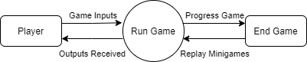

## Appendix D: Game Flowchart

## Appendix E: Storyboard Application

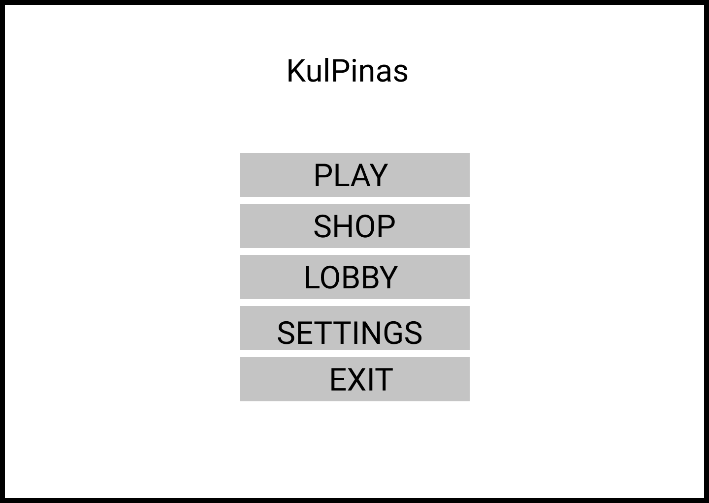

**Figure 8**. *Main Menu of the Game*

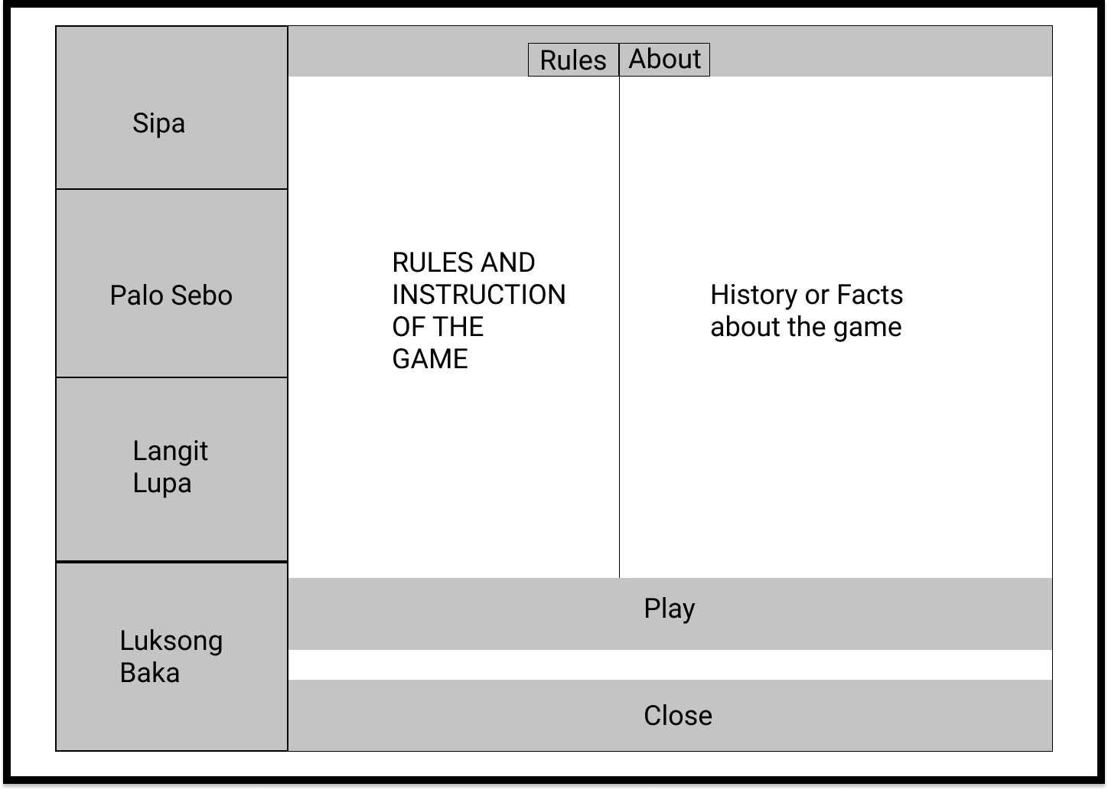

**Figure 9.** Game Selection

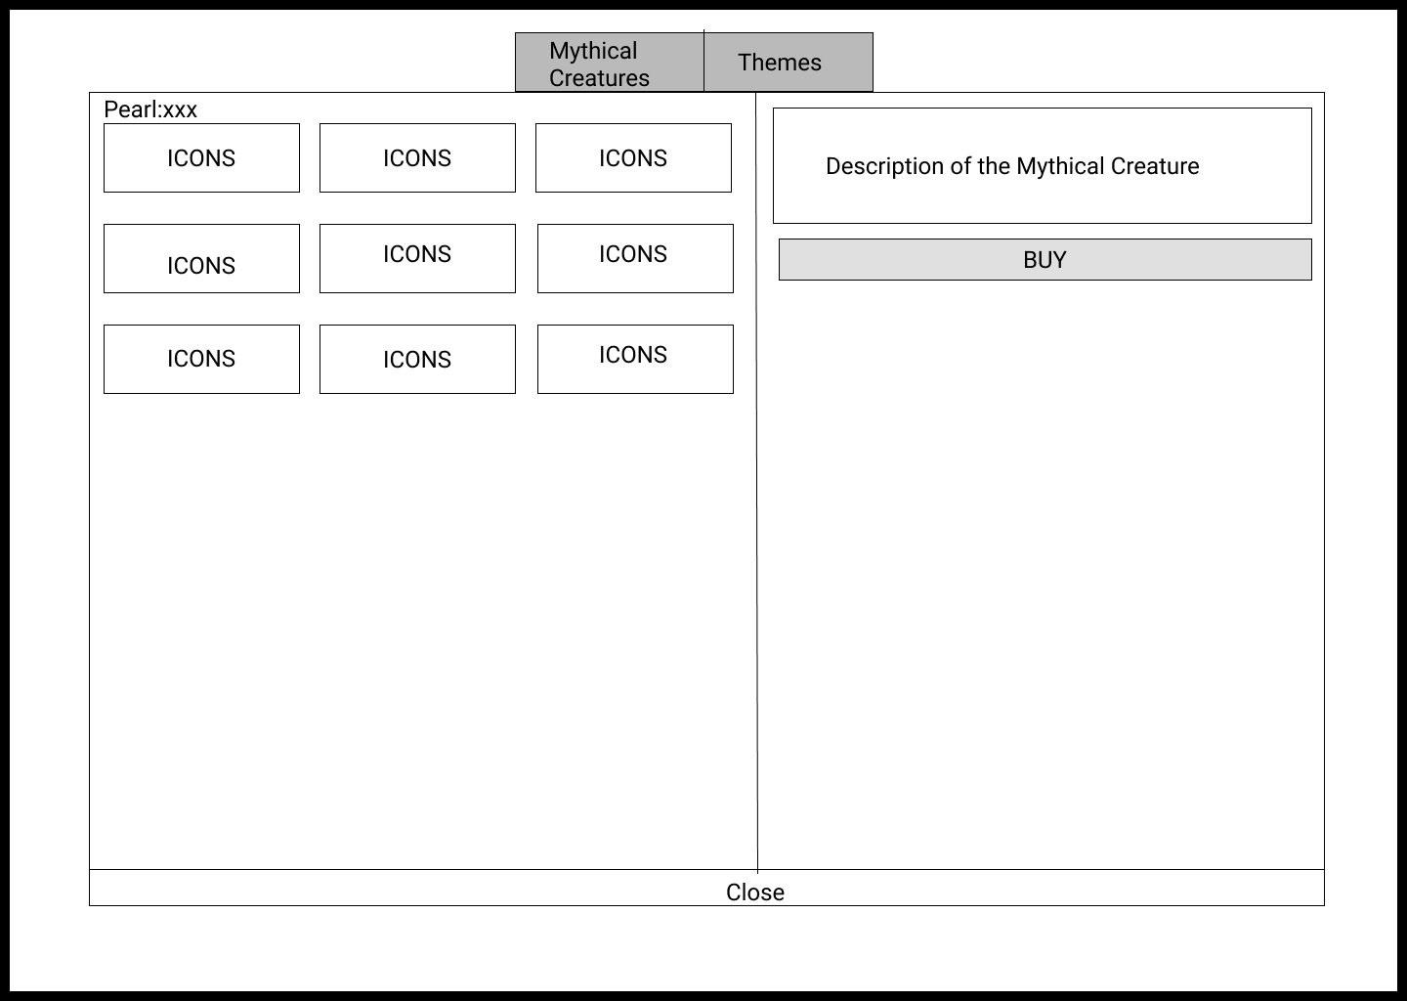

**Figure 10.** Shop Game

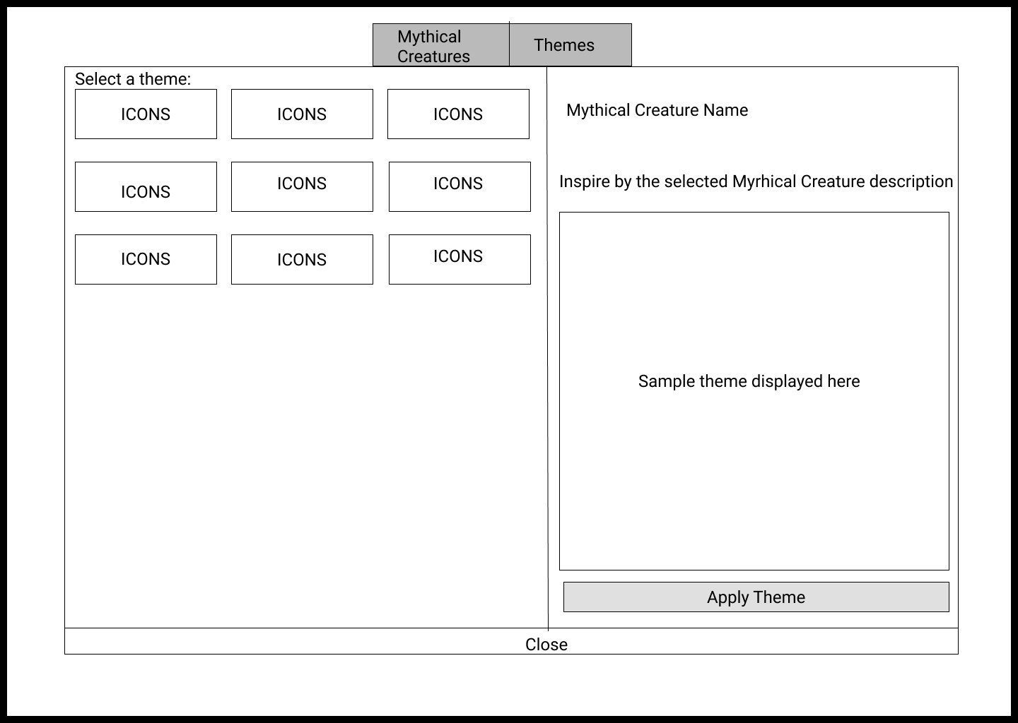

**Figure 11.** Theme Selection in the Game’s Shop

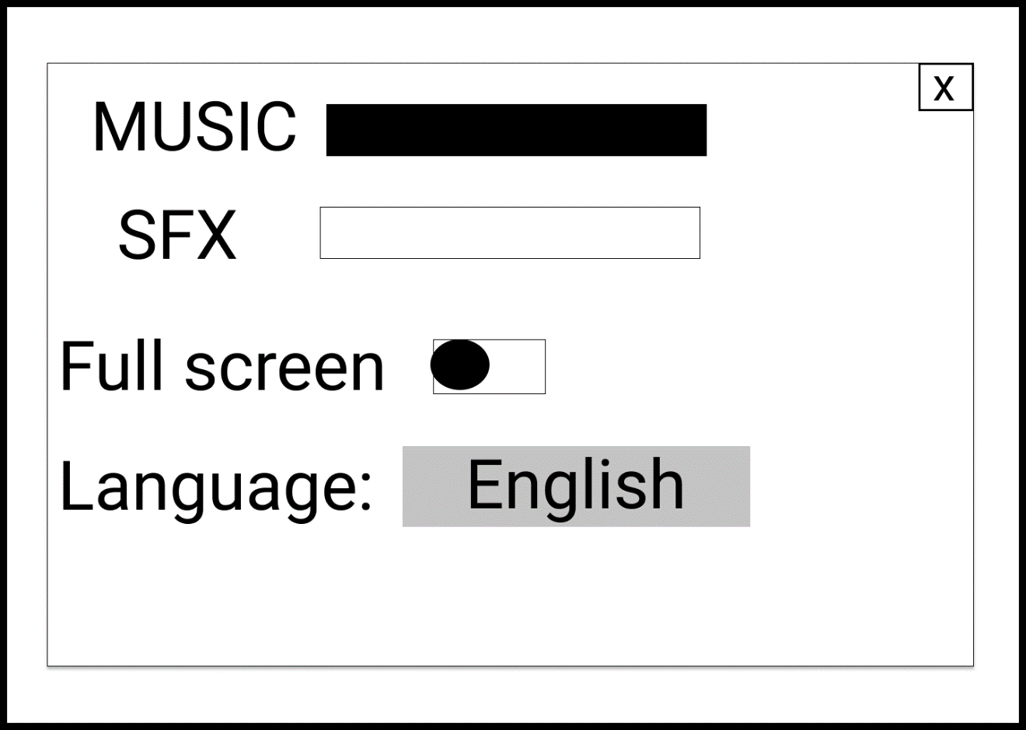

**Figure 12.** Option of the Game

## Appendix F: GUI Screenshots

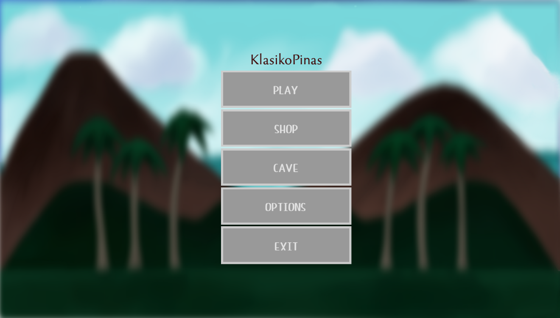

**Figure 13.** Main Menu of the Game

Figure 13 displays the main menu of the game. The buttons consist of Play,Shop, Cave, Options, and Exit.

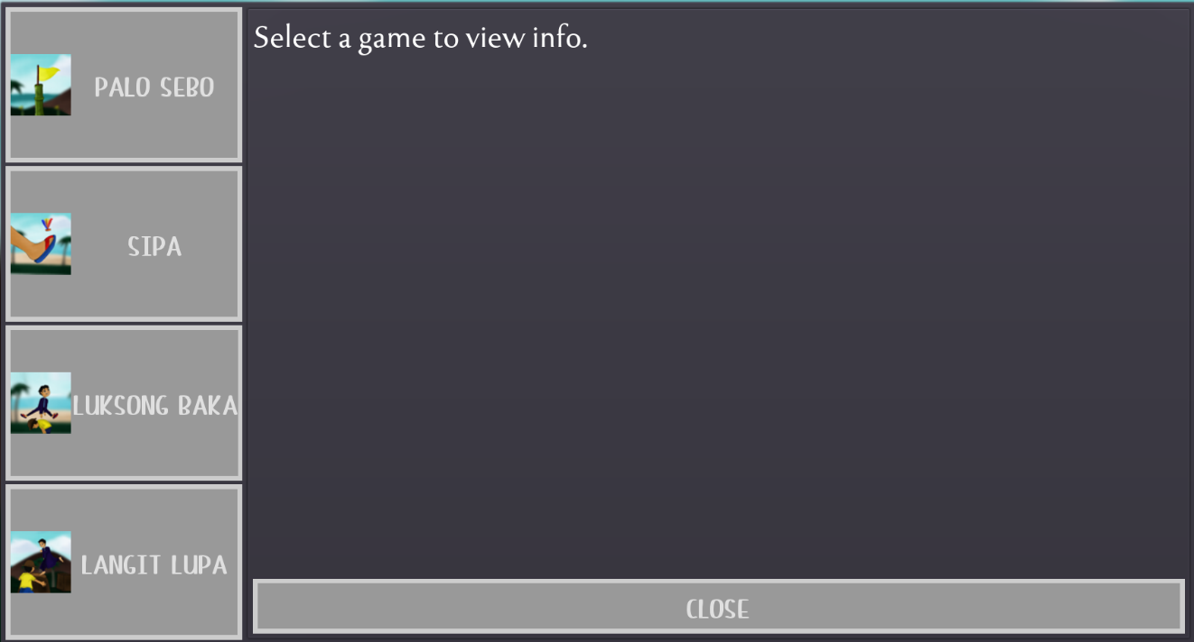

**Figure 14.**Selection Game

Figure 14 shows the traditional games you can select on the game. The traditional games you can choose are Palo Sebo, Sipa, Luksong Baka, and Langit Lupa. Each traditional games consist of rules in the game and some facts about them.

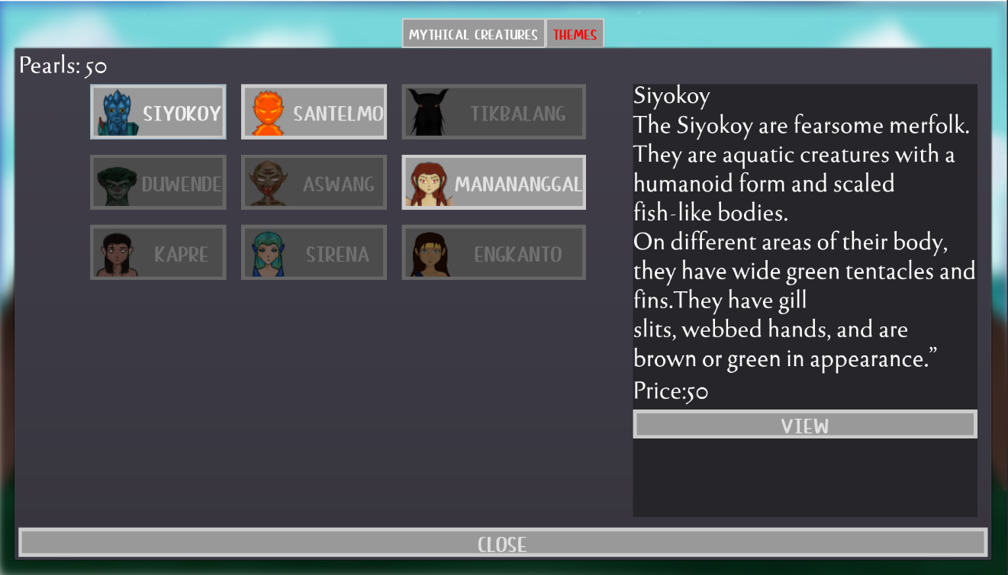

**Figure 15**. Mythical Creatures in Shop

Figure 15 shows the Shop of the game. The first tab is the Mythical Creatures, you can buy them through collecting pearls and defending in their prices. Each Mythical Creatures provides facts about them.

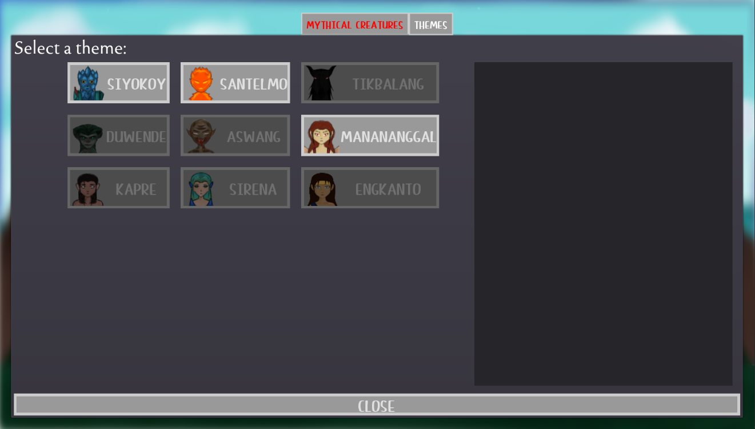

**Figure 16**. Themes in the Shop

In the figure 16 displays the second tab of the shop, the themes. Each mythical creatures have own unique themes that you can apply in the game.

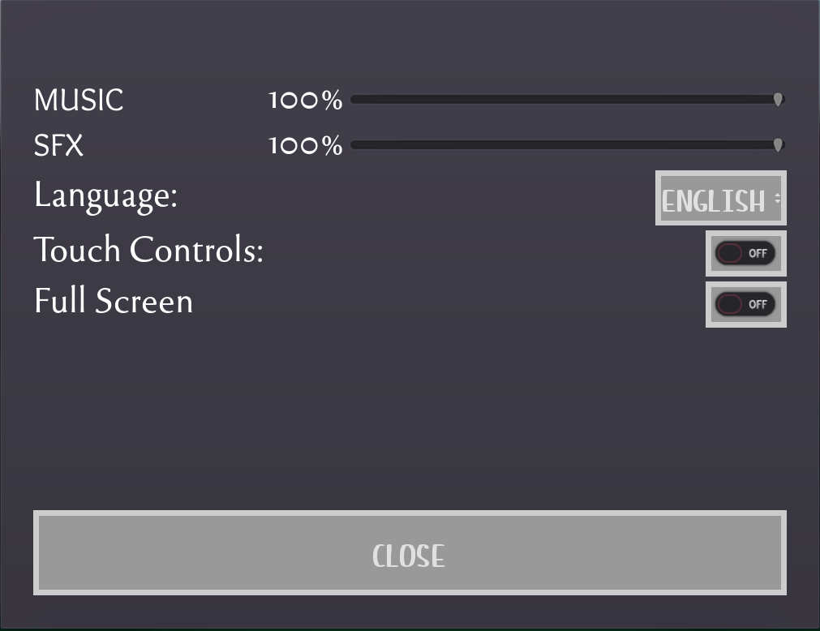

**Figure 17**. Option in the game

In the figure 17, it shows the Options in the game. You can adjust the sound of the game, full screen, and you can also change the language of the game. The language are Filipino and English.

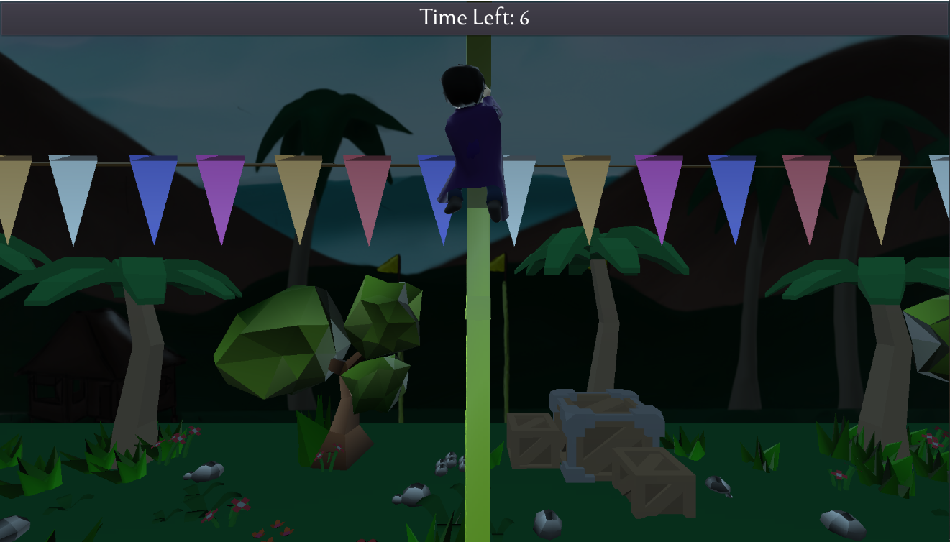

**Figure 18.** Palo Sebo Game

Figure 18 displays the Palo Sebo’s gameplay.

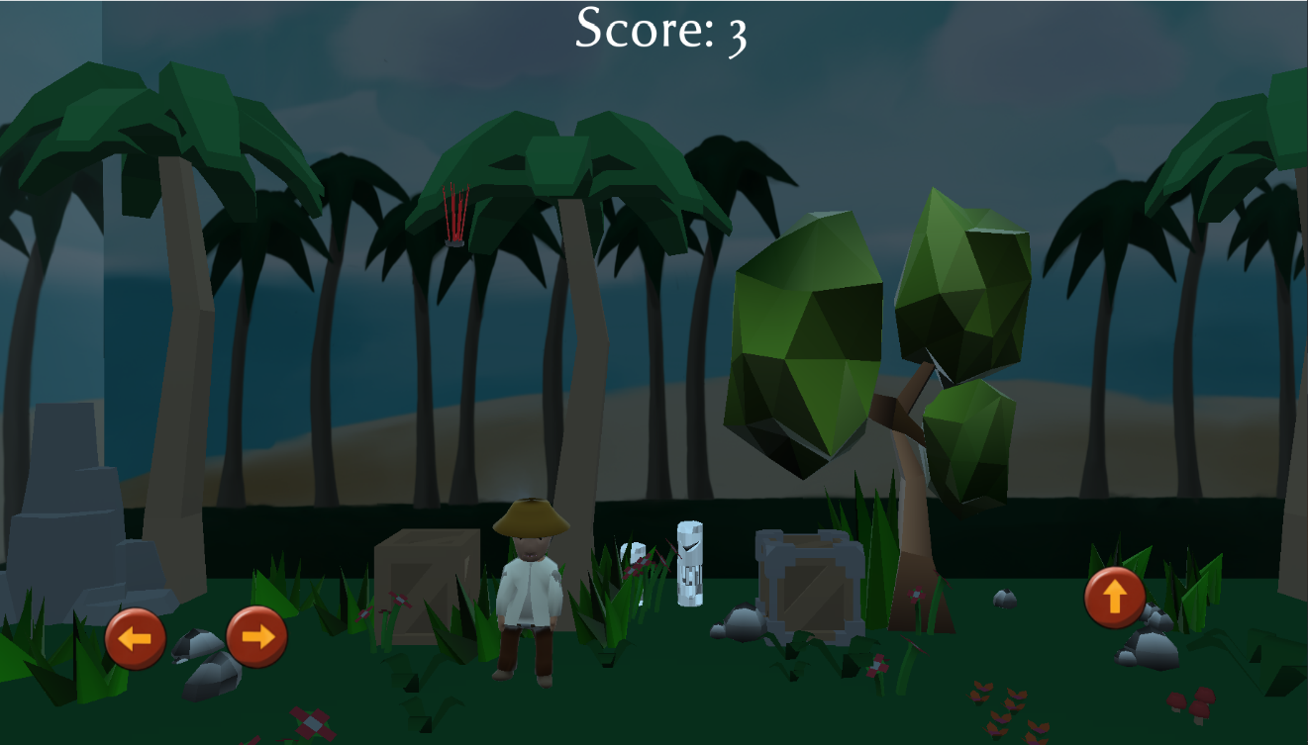

**Figure 19.** Sipa in the game

Figure 19 display the Sipa’s gameplay.

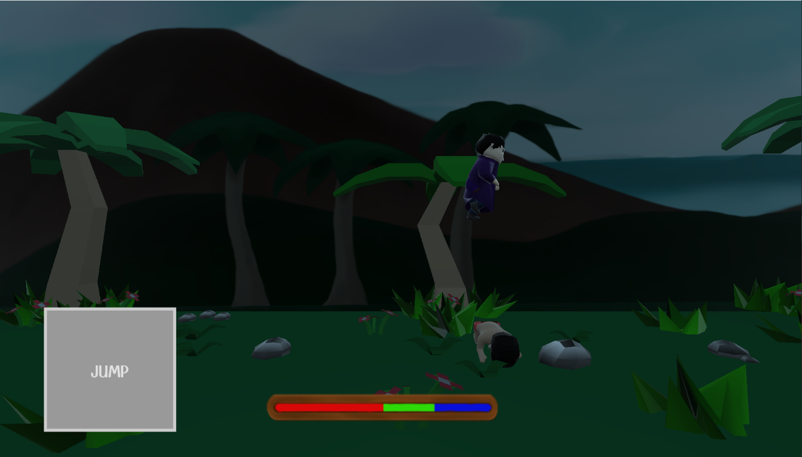

**Figure 20.** Luksong Baka in the game

Figure 20 shows the Luksong Baka’s gameplay

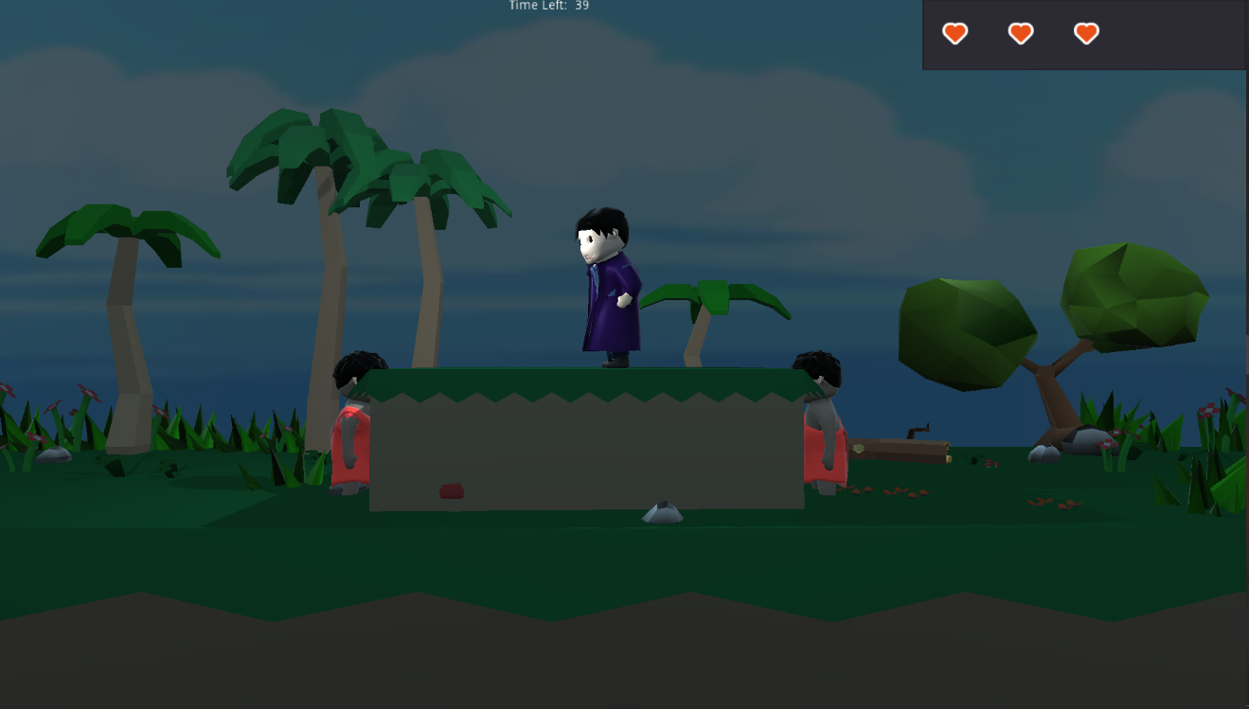

**Figure 21.** Langit Lupa in the game

Figure 201displays the Langit Lupa’s gameplay.

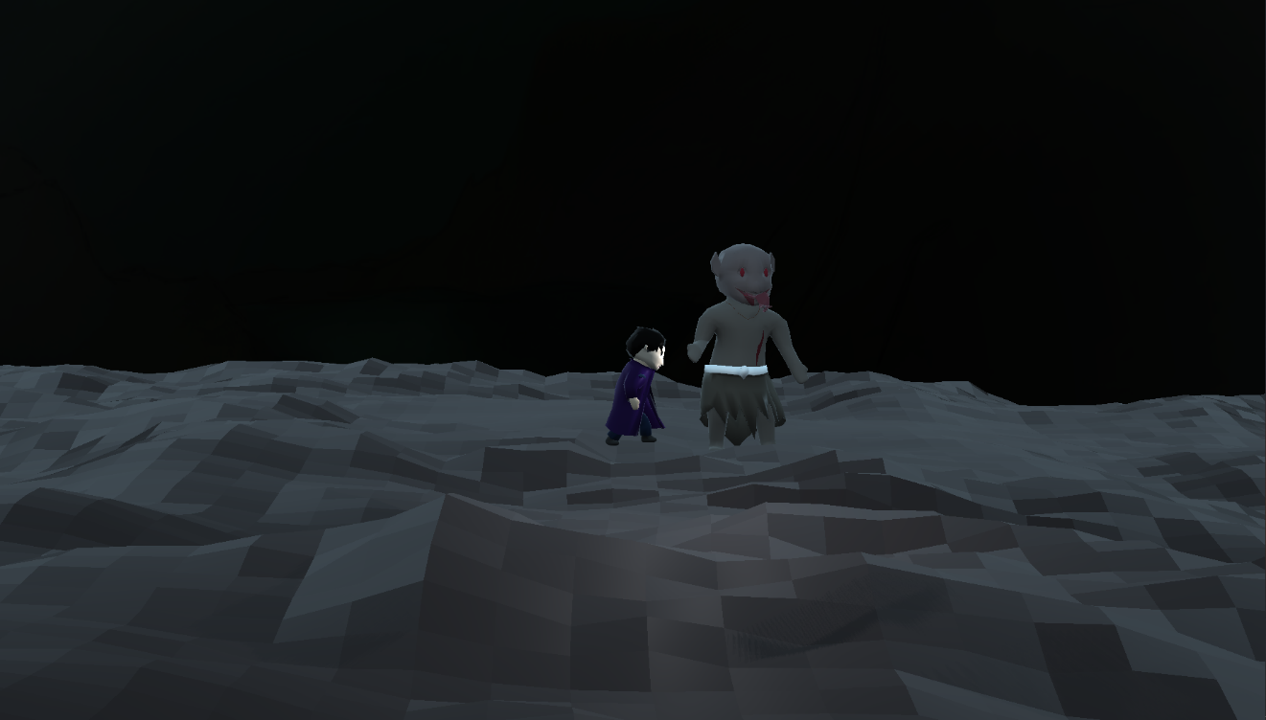

**Figure 22.** The cave in the game

In the figure 22. The cave is like a achievement room after purchasing a mythical creature in the shop. The cave allows you see the 3D model of the mythical creature that you already unlocked.

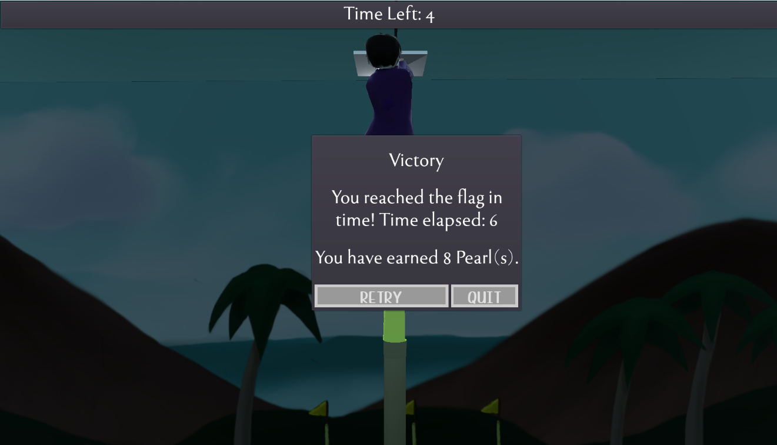

**Figure 23.** Victory UI in the game

Figure 23 shows the Victory result of the game.

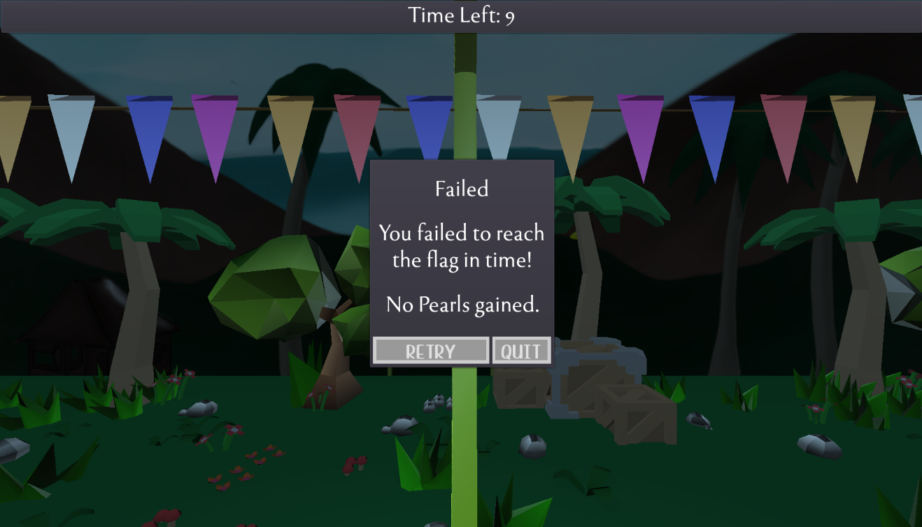

**Figure 24.** Fail UI in the game

Figure 24 shows the Failing UI in the game.

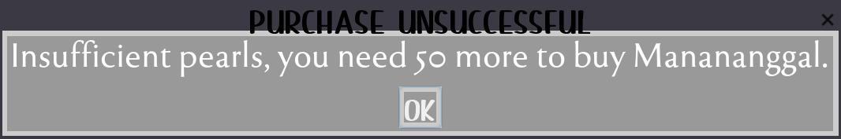

**Figure 25**. Purchased Unsuccessful UI in the Shop

Figure 25 shows the Pop up after a purchasing but lack of pearl.



**Figure 26.** Purchased Successfully UI in the game

Figure 26 shows after purchasing a mythical creature.

## Appendix G: Codes

Code of the player in the game

extends Character

signal interact

signal health_update(health)

signal dead()

var lives = 3

#Variable for storing velocity

var velocity: = Vector3()

#Which way is up

const UP: = Vector3(0,1,0)

#Interaction stuff

var can_interact = false

var jumps = 0

export var max_jumps = 1

onready var anim_tree = $"Armature/AnimationTree"

const MIN_BLEND_SPEED = 0.125

const BLEND_TO_RUN = .1

const BLEND_IDLE = 0.1

var movement_state = 0

var dir = 1 #-1 is left

var hasoffer = false setget toggle_offer

var base_z: float

var spawn

export (float) var max_health = 100

onready var health = max_health

func _ready():

g.in_game = true

base_z = translation.z

_speed = 10

_gravity = 50

_jump_force = 20

Dialogic.set_variable("name", g.player_name)

update_lives()

func update_lives():

get_tree().call_group("GUI" , "update_lives" , lives)

func _physics_process(delta):

#Player will always be affected by gravity, regardless of which state they are currently in.

velocity.y -= _gravity * delta

# print("base:", base_z, " ", translation.z)

#Check if current state matches any of the finite states

match current_state:

_state.IDLE:

jumps = 0

velocity.x = 0

velocity.y = 0

anim_tree["parameters/Fall/blend_amount"] = lerp(anim_tree["parameters/Fall/blend_amount"], 0, BLEND_TO_RUN)

anim_tree["parameters/Move/blend_amount"] = lerp(anim_tree["parameters/Move/blend_amount"], 0, BLEND_IDLE)

#Idle animation goes here.

if !$on_floor.is_colliding():#When platform break

self.current_state = _state.FALL

#$anim.play("idle")

#print("IDLE")

_move()#You can only move if you're idle/moving

_state.MOVE:

#print("MOVE")

velocity.z = 0

jumps = 0 if $on_floor.is_colliding() else jumps

_move()

anim_tree["parameters/Fall/blend_amount"] = lerp(anim_tree["parameters/Fall/blend_amount"], 0, BLEND_TO_RUN)

anim_tree["parameters/Move/blend_amount"] = lerp(anim_tree["parameters/Move/blend_amount"], 1, BLEND_TO_RUN)

#Damage indicator here

_state.INTERACT:#Interact code goes here

#print("INTERACT")

anim_tree["parameters/Move/blend_amount"] = lerp(anim_tree["parameters/Move/blend_amount"], 0, BLEND_IDLE)

velocity.x = 0

_state.JUMP:

_move()

anim_tree["parameters/Shot/active"] = true

if velocity.y < 0:

self.current_state = _state.FALL

_state.FALL:

anim_tree["parameters/Fall/blend_amount"] = lerp(anim_tree["parameters/Fall/blend_amount"], 1, BLEND_IDLE)

_move()

#print(is_on_floor(), $on_floor.is_colliding())

if is_on_floor() and $on_floor.is_colliding():

self.current_state = _state.IDLE

rotation_degrees.y = lerp(rotation_degrees.y, -30, .2) if dir == -1 else lerp(rotation_degrees.y, 110, .2)

velocity = move_and_slide(velocity, UP)

translation.z = base_z

func update_blessings(new_blessings: Array):

match new_blessings[0]:

-1:

$ilaw.hide()

max_jumps = 1

0:#Mermaid's Scale

max_jumps = 1

$ilaw.hide()

1:#Heaven's Floret

max_jumps = 2

$ilaw.hide()

2:#Wishing Star

max_jumps = 1

$ilaw.show()

_:

print(new_blessings[0])

func _move():

#Interaction control

if Input.is_action_just_pressed("interact") and can_interact and self.current_state == _state.IDLE:

self.current_state = _state.INTERACT

emit_signal("interact",self)

#Movement controls

if Input.is_action_just_pressed("move_up") and jumps < max_jumps:

self.current_state = _state.JUMP

#print("tomove")

velocity.y = _jump_force

jumps += 1

if Input.is_action_pressed("move_left"):

self.current_state = _state.MOVE if current_state == _state.IDLE else current_state

velocity.x = -_speed

dir = -1

# rotation_degrees = Vector3(0, lerp(rotation_degrees.y, -30, .2), 0)

elif Input.is_action_pressed("move_right"):

self.current_state = _state.MOVE if current_state == _state.IDLE else current_state

velocity.x = _speed

dir = 1

# rotation_degrees = Vector3(0, lerp(rotation_degrees.y, 110, .2), 0)

else:

#This makes sure na the current_state will only change kapag current_state == _state.MOVE

self.current_state = _previous_state if current_state == _state.MOVE else current_state

velocity.x = 0#Stop the player from moving"Armature"

#Check if player is falling

if velocity.y < 0 and !is_on_floor() and !$on_floor.is_colliding() and current_state != _state.FALL:

#print("falling at ", velocity.y)

#jumps += 1

anim_tree["parameters/Shot/active"] = false

self.current_state = _state.FALL

#The player can only interact one interactable at a time

func _on_interact_body_entered(body: Node):

#print(body.name)

#Connect the player to the interactable object, this way we can prevent having too many signals connected at a given time.

if body.is_in_group("interactable"):

can_interact = true

connect("interact", body, "_interact")

func _on_interact_body_exited(body: Node):

if can_interact:

can_interact = false

#Disconnect the player to the interactable object

if is_connected("interact", body, "_interact"):

disconnect("interact", body, "_interact")

func _on_interact_area_entered(area):

if area.is_in_group("interactable"):

can_interact = true

connect("interact", area, "_interact")

func _on_interact_area_exited(area):

if can_interact:

can_interact = false

#Disconnect the player to the interactable object

if is_connected("interact", area, "_interact"):

disconnect("interact", area, "_interact")

func toggle_offer(uhm):

hasoffer=uhm

func hurt():

lives -= 1

print(lives)

pass

func _on_Area_body_entered(body):

print(body.get_name())

pass # Replace with function body.

Shop code

extends Control

onready var texts: = $"items/tab_mythical/VBoxContainer/HBoxContainer/Panel/texts"

onready var preview: = $"items/tab_themes/VBoxContainer2/HBoxContainer/Panel/texts"

var fax: = preload("res://ui/fax.tscn")

var preview_scn = preload("res://ui/preview.tscn")

func _ready():

theme = load(g.theme) as Theme

$"items/tab_mythical/VBoxContainer/pearls".text = tr("pearls") + " " + str(g.pearls)

g.connect("new_pearls", self, "_update_pearls")

#Generate Store items---------------------------------------------------------------------------

for item in range(g.entries.size()):

var button = _generate_button(item)

button.connect("pressed", self, "_listing_pressed", [item])

if !g.entries[item]["owned"]:

button.self_modulate = Color(.5,.5,.5,1)

$"items/tab_mythical/VBoxContainer/HBoxContainer/listing".add_child(button)

#Generate Theme items---------------------------------------------------------------------------

for item in range(g.entries.size()):

var button = _generate_button(item)

button.connect("pressed", self, "_theme_pressed", [item])

if !g.entries[item]["owned"]:

button.self_modulate = Color(.5,.5,.5,1)

$"items/tab_themes/VBoxContainer2/HBoxContainer/listing".add_child(button)

func _generate_button(item: int) -> Button:

var button = Button.new()

button.name = str(item)

button.text = g.entries[item]["name"]

button.icon = load(g.entries[item]["icon"]) as Texture

return button

func _listing_pressed(item_id: int):

if texts.get_child_count() > 0:#Removew everything before placing new nodes

for child in texts.get_children():

child.queue_free()

var title: = Label.new()

var description: = Label.new()

var price: = Label.new()

var buy_button: = Button.new()

title.text = g.entries[item_id]["name"]

description.text = tr(g.entries[item_id]["description"])

description.clip_text=true

price.text = tr("Price" )+(":")+ str(g.entries[item_id]["price"]) + "○"

buy_button.connect("pressed", self, "_buy_pressed", [item_id, buy_button])

if !g.entries[item_id]["owned"]:

buy_button.text = tr("Buy")

else:

buy_button.text = tr("View")

texts.add_child(title)

texts.add_child(description)

texts.add_child(price)

texts.add_child(buy_button)

func _theme_pressed(item_id: int):

if preview.get_child_count() > 0:

for child in preview.get_children():

child.queue_free()

var title: = Label.new()

var description = Label.new()

title.text = g.entries[item_id]["name"]

preview.add_child(title)

description.text = "A menu theme inspired by " + g.entries[item_id]["name"] + ". Return to menu to apply changes properly."

preview.add_child(description)

if not g.entries[item_id]["owned"]:

description.text = "Buy to unlock preview."

else:

var new_preview: Control = preview_scn.instance()

var apply_button: Button = Button.new()

apply_button.text = "Apply Theme"

new_preview.theme = load(g.entries[item_id]["theme"]) if g.entries[item_id]["theme"] != "n/a" else null

apply_button.connect("pressed", self, "_apply_pressed", [g.entries[item_id]["theme"]])

preview.add_child(new_preview)

preview.add_child(apply_button)

func _buy_pressed(item_id: int, buy_button: Button):

if g.entries[item_id]["owned"]:

var fax_instance: Fax = fax.instance()

fax_instance.import_variables(tr(g.entries[item_id]["fax"]["info"]),

g.entries[item_id]["fax"]["image"],

g.entries[item_id]["fax"]["video"])

add_child(fax_instance)

fax_instance.popup_exclusive = true

fax_instance.popup_centered()

return

var warning = load("res://ui/warning.tscn").instance()

add_child(warning)

if g.pearls >= g.entries[item_id]["price"]:

#When item is bought, change button to view fax

g.pearls -= g.entries[item_id]["price"]

g.entries[item_id]["owned"] = true

$"items/tab_mythical/VBoxContainer/HBoxContainer/listing".get_node(str(item_id)).self_modulate = Color(1,1,1,1)

$"items/tab_themes/VBoxContainer2/HBoxContainer/listing".get_node(str(item_id)).self_modulate = Color(1,1,1,1)

buy_button.text = tr("View")

buy_button.release_focus()

warning.warn(get_tree(), "You bought " + g.entries[item_id]["name"] + ".", "Purchased successfully")

g.save()

else:

warning.warn(get_tree(), "Insufficient pearls, you need " + str(g.entries[item_id]["price"] - g.pearls) + " more to buy "+ g.entries[item_id]["name"] + ".", "Purchase unsuccessful")

func _apply_pressed(theme_path):

theme = load(theme_path) if theme_path != "n/a" else null

g.theme = theme_path

g.save()

func _update_pearls(current_pearls: int):

$"items/tab_mythical/VBoxContainer/pearls".text = tr("pearls") + " " + str(g.pearls)

func _on_close_pressed():

#loader.load_scene("res://ui/main_menu.tscn", self)

if get_parent().get_parent().has_node("player"):

get_parent().get_parent().get_node("player").current_state = 0

g.in_game = true

get_parent().toggle_menu(load("res://ui/shop.tscn"))

## Appendix H: Curriculum Vitae

**Basilio, Crisanto Sanchez**

Purok 3, San Jose Apunan,

Lubao, Pampanga

+63 9663729220

cs.crisantobasilio@gmail.com

**PERSONAL INFORMATION**

Date of Birth: August 23, 2000

Gender: Male

Height: 5’4”

Weight: 95 Kg

Civil Status: Single

Citizenship: Filipino

Religious Affiliation: Roman Catholic

Language/ Dialect: Capampangan, Filipino and English

**EDUCATIONAL ATTAINMENT**

Tertiary: **Don Honorio Ventura State University**

Bacolor, Pampanga

Bachelor of Computer Science

2022

Secondary: **San Vicente National High School**

San Vicente, Lubao, Pampanga

2016-2018

Primary: **San Jose Apunan Elementary School**

San Jose Apunan, Lubao, Pampanga

2006-2012

**CHARACTER REFERENCES**

**Ms. Aileen P. De Leon**

Instructor

Don Honorio Ventura State University

**Mr. Eden Garcia**

Chairperson

Don Honorio Ventura State University

**Mr. Joel D. Canlas**

Dean

Don Honorio Ventura State University

I hereby certify that the above information are true and correct to the best of my knowledge and belief.

**

Sta. Cruz, Lubao,

Pampanga

+63 9516695667

cs.limwellmalveda@gmail.com

**PERSONAL INFORMATION**

Date of Birth: December 13, 1999

Height: 5’7”

Weight: 95 Kg

Civil Status: Single

Citizenship: Filipino

Religious Affiliation: Roman Catholic

Language/ Dialect: Capampangan, Filipino and English

**EDUCATIONAL ATTAINMENT**

Tertiary: **Don Honorio Ventura State University**

Bacolor, Pampanga

Bachelor of Computer Science

2022

Secondary: **Sta. Cruz Academy**

Sta. Cruz, Lubao, Pampanga

2016-2018

Primary: **San Joaquin Elementary School**

San Joaquin, Sto. Tomas, Batangas

2006-2012

**CHARACTER REFERENCES**

**Ms. Aileen P. De Leon**

Instructor

Don Honorio Ventura State University

**Mr. Eden Garcia**

Chairperson

Don Honorio Ventura State University

**Mr. Joel D. Canlas**

Dean

Don Honorio Ventura State University

I hereby certify that the above information are true and correct to the best of my knowledge and belief.

**Pineda, Raymund Paolo Isip**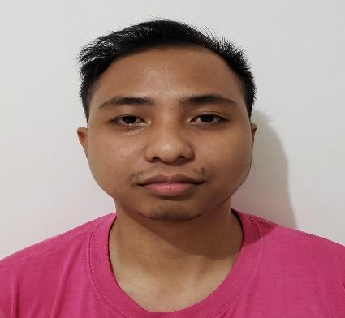

Zone 1, Becuran

Santa Rita, Pampanga

+63 9052987642

cs.raymundpaoloipineda@gmail.com

**PERSONAL INFORMATION**

Date of Birth: July 26, 1999

Gender: Male

Height: 5’0”

Weight: 54 Kg

Civil Status: Single

Citizenship: Filipino

Religious Affiliation: Roman Catholic

Language/ Dialect: Capampangan, Filipino and English

**EDUCATIONAL ATTAINMENT**

Tertiary: **Don Honorio Ventura State University**

Bacolor, Pampanga

Bachelor of Computer Science

2022

Secondary: **Becuran High School**

Becuran, Santa Rita, Pampanga

2016-2018

Primary: **Becuran Elementary School**

Becuran, Santa Rita, Pampanga

2006-2012

**CHARACTER REFERENCES**

**Ms. Aileen P. De Leon**

Instructor

Don Honorio Ventura State University

**Mr. Eden Garcia**

Chairperson

Don Honorio Ventura State University

**Mr. Joel D. Canlas**

Dean

Don Honorio Ventura State University

I hereby certify that the above information are true and correct to the best of my knowledge and belief.

**Ramirez, John Russel Bugarin**

Blk 2 lot 102 Apalit Resettlement Area,

Floridablanca, Pampanga

+63 9516695667

cs.johnrusselbramirez@gmail.com

**PERSONAL INFORMATION**

Date of Birth: June 25, 1999

Gender: Male

Height: 5’8”

Weight: 95 Kg

Civil Status: Single

Citizenship: Filipino

Religious Affiliation: Roman Catholic

Language/ Dialect: Capampangan, Filipino and English

**EDUCATIONAL ATTAINMENT**

Tertiary: **Don Honorio Ventura State University**

Bacolor, Pampanga

Bachelor of Computer Science

2022

Secondary: **Saint Augustine Academy of Pampanga**

Poblacion, Floridablanca, Pampanga

2016-2018

Primary: **Apalit Elementary School**

Apalit, Floridablanca, Pampanga

2006-2012

**CHARACTER REFERENCES**

**Ms. Aileen P. De Leon**

Instructor

Don Honorio Ventura State University

**Mr. Eden Garcia**

Chairperson

Don Honorio Ventura State University

**Mr. Joel D. Canlas**

Dean

Don Honorio Ventura State University

I hereby certify that the above information are true and correct to the best of my knowledge and belief.

**Sanchez, Seinthe Rivera**

Sitio Baluyut, San Francisco,

Lubao, Pampanga

+63 9274239550

cs.seinthesanchez@gmail.com

**PERSONAL INFORMATION**

Date of Birth: February 07, 2000

Gender: Male

Height: 5’5”

Weight: 55 Kg

Civil Status: Single

Citizenship: Filipino

Religious Affiliation: Roman Catholic

Language/ Dialect: Capampangan, Filipino and English

**EDUCATIONAL ATTAINMENT**

Tertiary: **Don Honorio Ventura State University**

Bacolor, Pampanga

Bachelor of Computer Science

2022

Secondary: **Saint Augustine Academy of Pampanga**

Poblacion, Floridablanca, Pampanga

2016-2018

Primary: **Saint Augustine Academy of Pampanga**

Poblacion, Floridablanca, Pampanga

2006-2012

**CHARACTER REFERENCES**

**Ms. Aileen P. De Leon**

Instructor

Don Honorio Ventura State University

**Mr. Eden Garcia**

Chairperson

Don Honorio Ventura State University

**Mr. Joel D. Canlas**

Dean

Don Honorio Ventura State University

I hereby certify that the above information are true and correct to the best of my knowledge and belief.

**Santos, Francis Ford Laxa**

Sitio Baluyut, Sindalan,

San Fernando, Pampanga

+63 9760089356

cs.francisfordsantos@gmail.com

**PERSONAL INFORMATION**

Date of Birth: September 24, 1999

Gender: Male

Height: 5’8”

Weight: 49 Kg

Civil Status: Single

Citizenship: Filipino

Religious Affiliation: Iglesia ni Cristo

Language/ Dialect: Capampangan, Filipino and English

**EDUCATIONAL ATTAINMENT**

Tertiary: **Don Honorio Ventura State University**

Bacolor, Pampanga

Bachelor of Computer Science

2022

Secondary: **New Era University**

Dela Paz Norte, San Fernando, Pampanga

2016-2018

Primary: **Jesus Mighty Faith Academy**

Sindalan, San Fernando, Pampanga

2006-2012

**CHARACTER REFERENCES**

**Ms. Aileen P. De Leon**

Instructor

Don Honorio Ventura State University

**Mr. Eden Garcia**

Chairperson

Don Honorio Ventura State University

**Mr. Joel D. Canlas**

Dean

Don Honorio Ventura State University

I hereby certify that the above information are true and correct to the best of my knowledge and belief.